
International Student and Scholar Services
Admission Policy Guide
2023

TABLE OF CONTENTS
1 Introduction 3
Purpose of this document 3
2 ISSS Admission Policies 4
2.1 Immigration Documents issued by ISSS Office at AU 4
2.2 Immigration documents process. 6
2.3 Form I-20/DS-2019 Program Start and End Dates 10
2.4 International Students Cost Guides. 15
2.5 Required documents to issue Form I-20/DS2019 23
2.6 English Language Proficiency (ELP) Requirements 29
2.7 Memorandum of Agreement (MOA) 35
2.8 J-1 students in Degree Programs 36
2.9 Follow-up with students & Reminder E-mails. 37
3 Policies for Admission OfficeS 38
3.1 Steps before Submitting PIIRFs in iEagle 38
3.2 Submitting a PIIRF in iEagle 46
3.3 I-20/DS-2019 Distribution Policy…………………………………………………………………………………………………………………..
3.4 Changing Majors or Programs………………………………………………………………………………………………………………………
3.5 Deadlines for PIIRF Submission…..…………………………………………………………………………………………………………………..
3.6 Communication with Admission Units……………………………………………………………………………………………………………
4 Creating Immigration Documents 55
4.1 Initial Immigration Documents 55
4.2 Immigration Transfer 64
4.3 Change of Level (COL) 69
4.4 Dual Degrees 73
4.5 Change of Status (COS) 76
4.6 Returning from Approved Leave of Absence (RLOA) 79
4.7 Major Changes 82
4.8 Withdrawals & Deferrals 83
4.10 Late Arrivals 84
5 Visa & Immigration Registration 86
5.1 Visa & Advising Flowchart 86
5.2 Initial & Transfer Student Registration and Validation Flowchart 87
6 Common questions & answers 88
6.1 Q&A for ISSS Front Desk Staff 88
6.2 Q&A for Admission Offices 90
7 Appendix: How to update this document 92

Introduction

Purpose of this document
This document serves as a comprehensive guide specific to American University International Student and Scholar Services’ (ISSS) admission policies and procedures. The scope of the information includes types of immigration documents created by the ISSS office, required information/documents to create immigration documents, DHS requirements, and ISSS office policies.
This manual also covers preparing and creating the international student cost guides, English Proficiency requirements and updates, program dates for each school, and communication with students. Additionally, it contains detailed information needed by the Admission Offices at AU, covering all aspects of immigration documents requirements and policies, and submitting immigration documents requests (PIIRFs) in Sunapsis, ISSS’s international student database.
This manual can be used for training new DSOs about the admission area policies and procedures, including step-by-step instructions about creating initial and transfer immigration documents for different student groups and understanding policies surrounding major changes, withdrawal and deferrals, and late arrivals.

ISSS Admission Policies

2.1 Immigration Documents issued by ISSS Office at AU
American University is authorized to issue an I-20 "Certificate of Eligibility for Nonimmigrant Student Status" and DS-2019 "Certificate of Eligibility for Exchange Visitor (J-1) Status" for students admitted to full-time, degree-seeking programs.
Degree Programs: In order to be eligible for immigration document issuance, each program of study should be a full-time program in the AU academic catalog with documented admissions standards. A minimum of 9 credits enrollment is required for graduate level (with the exception of JD, which is 12 credits, and LLM & SJD, which are 8 credits), and 12 credits for undergraduate level for each fall/spring semester. Students should receive a degree or certificate of completion at the end of the program.
Graduate Certificate Programs: Students should be enrolled full-time for 9 credits each semester.
Exchange Programs: American University issues immigration documents for students who are enrolled in degree-seeking programs in their home institution and are taking classes for one semester, one year, or two years at AU based on the exchange agreements (MOAs) between American University and their home institution.
Non-Degree Short Programs: American University does not issue immigration documents for non-degree programs, other than English Language Training Academy (ELTA) and American Access (ACDC). The immigration document is issued for at least one year.
International Accelerator Program (IAP): American University issues immigration documents for pathway programs for students who are conditionally approved to degree-seeking programs at AU.
Most American University international students hold F-1 visa status; however, some students may be eligible for or required to have J-1 visa status. Students requesting the Certificate of Eligibility for Nonimmigrant Student status (Form I-20) will apply for an F-1 student visa, and students requesting a Certificate of Eligibility for Exchange Visitor Status (DS-2019), will apply for a J-1 exchange visitor visa.
Students who are unsure of which visa to choose may review our webpage here: https://www.american.edu/ocl/isss/upload/f1-and-j1-student-visa-comparison.pdf.

F-1 Student Visa Status 8 CFR 214.2(f)
The F-1 is the most common visa for students studying in the United States. Full-time, degree-seeking students at AU are eligible for the F-1 visa.

J-1 Exchange Visitors Status 22 CFR Part 62
To be eligible for J-1 status, the prospective student must meet the following criteria:
- The student or his or her program are financed directly or indirectly by:
(i) The United States Government;
(ii) The government of the student's home country; or
(iii) An international organization of which the United States is a member by treaty or statute.
- The program is carried out pursuant to an agreement between the United States Government and a foreign government.
- The program is carried out pursuant to written agreement between:
(i) American and foreign academic institutions, such as Abroad at AU or Washington Semester Program;
(ii) An American academic institution and a foreign government; or
(iii) A state or local government in the United States and a foreign government; or
- Student is supported substantially by funding from any source other than personal or family funds.

2.2 Immigration Documents Process
Students must first be admitted to American University before ISSS can begin processing their immigration paperwork. After they are admitted, they will need an immigration document (I-20 or DS-2019) to apply for an F-1 or J-1 visa at a U.S. Embassy or Consulate in their country.

Below are the steps the student needs to take to receive an I-20 or DS-2019 from the ISSS office at AU:

Step 1: Student submits the deposit to their Admission Office

After the student is admitted to American University, they must submit their deposit (if required by the admission office). A deposit is generally required before any immigration document is issued (for more information on deposits, the student should contact their admission office, or the student should refer to their letter of admission for instructions). Admissions units should not send PIIRFs to ISSS without a deposit confirmed, if applicable.

Step 2: Student submits Passport, CFIS Form, and Supporting Financial Proof to the Admission Office

All F-1 students are required to demonstrate financial ability to pay for at least one year of expenses for their program of study. All J-1 students are required to demonstrate financial ability to pay for the entire length of their program of study. Program cost includes tuition, fees, and living expenses, and is indicated in the International Student Cost Guides prepared by ISSS.

- For the estimated costs of their program of study, a student should visit: https://www.american.edu/student-affairs/isss/cost-guides.cfm

- Student must submit a completed Certification of Finances for International Students Form (CFIS) and supporting financial proof to their admission office. The CFIS Form can be found at https://www.american.edu/student-affairs/isss/upload/cfis_2023.pdf. For additional sources of funds that will not fit on the CFIS, student should also complete the form “Attachment A: Additional Sources of Funds,” which is located here https://www.american.edu/student-affairs/isss/upload/cfis-form-attachment-a.pdf.

- All supporting financial documents must be in English or accompanied by a certified English translation showing available, liquid funds. The financial documents cannot be older than three months at the time of submission to the admitting unit in order to be considered valid. For more information about acceptable financial documents, students can visit: https://www.american.edu/student-affairs/isss/financial-documents.cfm.

- If an F-1 student is transferring to American University from another U.S. institution, they must submit the Transfer-In e-Form in iEagle (ieagle.american.edu). J-1 transfer-ins should contact isssdocuments@american.edu to discuss their eligibility for transfer.
For additional information on the academic transfer process, students should visit the New Transfer Student webpage. This page is a central hub of information for both admitted and deposit-paid transfers.
Students transferring their immigration status from another U.S. institution can remain in the U.S. between programs, even if their visa has expired. To re-enter the U.S., the student must have a valid visa with an expiration date in the future. The F-1 visa received from their previous school can still be used with the new AU I-20 issued by American University if it expires in the future. If their visa has expired, the student must apply for a new visa with the I-20 issued by American University before returning to the U.S.
Step 3: Admission office submits a PIIRF to ISSS office
After all required documents are received by the admission office from the student, the admission office will send a Personal and Immigration Information Request Form (PIIRF) to the ISSS office in iEagle. The PIIRF is proof of admission and applicable deposit to the university and is the official request for an immigration document from the admission office.
Any issues that may arise during the PIIRF review process may delay the issuance of the immigration document. If issues do arise, ISSS will contact the student through both their AU email account and the email that the student provided at the time of their application. The student should contact their admissions office if they would like to change their email address or mailing address.

For Washington Semester Program, Abroad at AU students, and IAP programs, ISSS contacts the admission department directly when issues arise in the PIIRF review process.

Step 4: Student receives their Immigration Document
Once a complete PIIRF is received, the I-20 or DS-2019 will be issued within 3-5 days. If the student is issued an I-20, the form will be made available for download in iEagle (DHS guidance on electronic I-20 issuance can be reviewed here).

As of April 27, 2023, sponsors may now also digitally sign and electronically submit DS-2019s to exchange visitors. More information about electronic DS-2019 issuance can be found here.

Along with their I-20 or DS-2019, the student will receive a link to the pre-arrival guide with information about the next steps of the immigration process, as well as instructions to complete their required pre-arrival forms in iEagle.

The “Departmental Contact” should be copied on the PIIRF approval message to the student so that they are aware the immigration document has been issued for that student. The Departmental Contact in Sunapsis is the person who submitted the PIIRF.

Step 5. Student must pay the mandatory I-901 SEVIS Fee
Before applying for an F-1 or J-1 visa, all first-time visa applicants are required to pay the SEVIS fee in addition to the visa application fee. Students must print and save their SEVIS fee payment receipt.
Step 6. Student will schedule a visa appointment
After receiving the immigration document and paying the SEVIS fee, the student will need to apply for their F-1/J-1 visa at the U.S. Embassy or Consulate in their country.
Students should visit the U.S. Department of State website for information on how to apply for the F-1/J-1 student visa. They should also see our Tips for a Successful Visa Interview and Visa Wait Times for more information.
At certain embassies, students may be placed in “administrative processing,” during which the consular officer requires more time to review the student’s file. In these cases, students must keep ISSS and their admissions office up-to-date so that if they do not receive their visa in time, appropriate next steps can be taken on their immigration document. The student should work with admissions to either defer or withdraw their admission, and ISSS will then either update the I-20 start and end dates or cancel the I-20. More information about administrative processing can be found here: https://travel.state.gov/content/travel/en/us-visas/visa-information-resources/administrative-processing-information.html.
Step 7. Student enters the U.S. to pursue their studies and reports to ISSS office
Based on immigration requirements, the student is required to enter the U.S. on or up to 30 days before the start date on their immigration document I-20/DS-2019, but not after.
If the student is not able to arrive by the start date of their program, they must contact the ISSS office immediately. Please see the section on late arrivals for more information.
After arrival to the U.S., students must complete their mandatory immigration registration in iEagle as soon as possible so that their record can be registered or validated in SEVIS.

2.3 Form I-20/DS-2019 Program Start and End Dates
Immigration documents’ program length is determined by the total number of credits required for each program and the time needed for the international students to complete their program of study based on full-time enrollment. The length of study is determined by the admission units and cannot be changed based on individual students’ requests.

The start and end dates for each program follow the university’s Academic Calendar for each academic year posted on AU’s and WCL’s website, and they are confirmed with the Admission offices for any possible changes (especially for the SOC Boot Camp, Summer Human Rights Academy and other Hybrid LLMs, ELTA summer and IAP summer progressing programs).

The I-20/DS-2019 end date cannot be before the official AU session end date (last date of classes found on the AU Academic Calendar). If a student is graduating before the I-20 end date, ISSS will shorten the length of the I-20.

American University is certified to issue immigration documents with Fall and Spring Semester start dates. Summer is not considered an official semester. The ISSS office does not issue immigration documents with the start date of summer for any programs (with the exceptions of ELTA, pre-sessional programs, WCL Human Rights Academy and other Hybrid LLMs, and SOC boot camp programs). This is for the below reasons:

- First, for immigration purposes, summer session is not considered a separate semester, and under our SEVIS authorization (form I-17), we cannot issue I-20s for international students starting a new program with a summer start date.
- Second, an initial international student must be registered full-time to maintain immigration status. This means for the summer, the student would need to be registered for 9 credits (graduate) and 12 credits (undergraduate) to be considered full time. With the short length of the summer session, and with not many class choices offered, it may be impossible for the student to maintain full-time status. In addition, summer classes can be cancelled last minute, and the student risks falling out of immigration status.
- Third, summer courses are very intense, and academic adjustment becomes even more challenging for incoming international students.

Note: In rare cases when we do issue immigration documents with a summer start (such as for student athletes), the start and end dates are determined per individual circumstance by the admission office and/or academic department. The summer start date should always be approved by the ISSS director. The student and Academic Advisor must have an academic plan to guarantee full-time enrollment for the summer (UGA is 12 credits for both summer sessions and 9 credits for Graduate programs).

The I-20/DS-2019 Program Start and End Dates charts are created for each Fall and Spring Semester (and summer, where applicable). These charts are used when creating admission templates in Sunapsis for immigration document creation. Usually, the Fall semester chart is created in February, and the Spring semester chart is created in September.

The I-20 & DS-2019 Start and End Dates charts are saved in the K-drive (K:\ISSS\ADMISSIONS\I-20 and DS-2019 PROGRAM DATES), and are created each academic year following the instructions below:

- Short-Term Programs (Abroad at AU, Washington Semester)

The start and end dates for the short-term programs are derived from the AU Academic Calendar as follows:

Fall and Spring:
Start Date = Start of Classes for the Spring or Fall Semester from AU Academic Calendar
End Date = The last day of exams from the AU Academic Calendar (dependent upon whether the student is completing one semester or one year)

- ELTA, IAP, MAP, ACDC

Fall and Spring:

Start Date = Start of Classes for the Spring or Fall Semester from AU Academic Calendar
End Date = Depending on the length of the program
Spring end date = Commencement Day (Second Sunday in May).
Fall end date = Commencement Day for fall

Summer Session:

Contact and confirm with the Admission Contact for each program directly. Check most recent contact sheet saved here: K:\ISSS\ADMISSIONS\DIRECTORY

Start date = First day of the 6-week summer session
End date =the last day of classes for the second session

Please note: for summer ELTA, the admission office must confirm the below before we can create immigration documents:
- The students will have full-time enrollment (minimum 18 clock hours)
- One of the below is met (PIIRF remarks should specify this)
TEST | Fall 2023 | from Spring 2024 onwards
ELTA In-house Test & Interview | - | 10+
DET | 65+ | 65+
TOEFL iBT | 50+ | 50+
IELTS | 4.5+ | 4.5+
iTEP | 2.5+ | 2.5+

IAP Summer Progression= Confirmed with IAP directly (check most recent contact here: K:\ISSS\ADMISSIONS\DIRECTORY)

- Undergraduate Programs

The start and end dates for the regular bachelor’s programs are derived from the AU Academic calendar as follows:

Start Date = First day of classes for the Spring or Fall Semester from AU Academic Calendar
End Date = Spring end date: Commencement Day (Usually second Sunday in May)
Fall end date: Commencement Day for fall

The program length for regular undergraduate program is 48 months.

- Graduate Programs

The start and end dates for graduate programs are derived from the AU Academic calendar as follows:

Start Date = Start of Classes for the Spring or Fall Semester from AU & WCL Academic Calendar
End Date = Depending on the length of the program confirmed with each school:

Spring end date = Commencement Day, Second Sunday in May (WCL has a different commencement date)
Fall end date= Commencement Day for fall
Summer end date= Exactly the length of the program for Summer

Program lengths for graduate programs:

- CAS, SOE, SIS MA/MS= 28 months
- SPA MA/MS = 24 months
- KSB MS = 24 months
- KSB MBA = 36 months
- CAS MFA = 36 months
- CAS, SIS, SPA PhD = 84 months

SOC programs lengths vary from 12-36 months:
- SOC PhD = 36 months
- Journalism MA = 13 months (includes 1 month of boot camp)
- Strategic Communication MA = 16 months
- Political Communication MA = 24 months
- Game Design MA = 24 months
- Film & Media Production MA = 25 months (includes 1 month of boot camp)
- Games & Interactive Media Film & Media Arts (MFA) = 37 months (includes 1 month of boot camp)

Boot camp program start dates are confirmed with the SOC Admission office directly. (Check most recent contact here: K:\ISSS\ADMISSIONS\DIRECTORY)

- LLM, SJD, JD, External Dual JD

Start Date = Start of Classes for the Spring or Fall Semester
End Date = Depending on the length of the program

Spring end date = Commencement Day (Typically third Sunday of May, but should be verified with WCL registrar)
Fall end date = WCL Official Degree Award Date (Typically December 21)
Summer end date = Exactly the length of the program

- LLM = 16 months
- SJD = 48 months
- JD = 36 months
- Dual JD = 24 months
Summer Human Rights and Hybrid LLMs: The summer session is held in June and is three weeks. Human Rights Academy is a Hybrid program taught online, in Spanish or English, and students come for the in-person session for about one month. Students have the option to do one summer plus one semester as well. WCL also has other Hybrid LLM programs that have the same in-person options. In these cases, I-20 is issued for Summer alone, or summer plus Fall or Spring.
Dates are confirmed with WCL LLM Admission office. (Check most recent contact here: K:\ISSS\ADMISSIONS\DIRECTORY)

- WCL 1 Semester Certificate Programs

The start and end dates are derived from the AUWCL Calendar and approved by the admission units:

Start Date = Start of Classes for the Spring or Fall Semester
End Date = Spring: Commencement Day (Typically third Sunday of May, but should be verified with WCL registrar)
Fall: WCL Official Degree Award Date (Typically December 21)

- 1-Year Graduate Certificates offered by CAS, SIS, SPA

The graduate certificates are issued for 12 months. The start and end dates for these programs are derived from the AU Academic calendar as follows, unless they are determined by the admission units:

Start Date = Start of Classes for the Spring or Fall Semester
End Date = Exactly 12 months

- SIS Exchange Programs

SIS exchange programs are issued for one semester to 2 years. These program dates and cost guides are developed with the current SIS exchange advisor (check most recent contact here: K:\ISSS\ADMISSIONS\DIRECTORY)

2.4 International Students Cost Guides
The International Student Cost Guides are created to communicate the approximate costs of living and attendance per program of study for the purpose of creating immigration documents.

In order to receive an immigration document, all F-1 students must show proof of sufficient funds to cover the costs of the first year of their program of study, and all J-1 students must show proof of sufficient funds for the entire length of their program of study.

There are different costs for each AU program of study. The costs of each program are posted on the ISSS webpage at Cost Guides for International Students.

All cost guides are developed after ISSS receives the information below:

- American University’s one or two-year budget approval from the University’s Board of Trustees, which is available approximately in late February (Received by ISSS director)
- Cost-of-Living and Attendance from AU Financial Aid office in early March (Contact Associate Director of AU financial Aid office)
- WCL financial aid is contacted for the Cost of living and Attendance for WCL programs
- Special Programs (Abroad at AU, WSP, ELTA, IAP) are contacted directly to determine tuition cost, fees and living expenses (Email admission contact for each department: K:\ISSS\ADMISSIONS\DIRECTORY)
- AU Health Insurance fee is taken from AU Central’s website. This fee reflects the previous academic year fee because the Health Insurance fee is always updated in the month of May, and the cost guides are updated in early March
- Once the cost guides are created, admission offices review and confirm before we post them on ISSS webpage. Final cost guides can also be found here: K:\ISSS\ADMISSIONS\COST GUIDES

Cost Guides for each program are calculated as follows:

Undergraduate Programs
The Cost Guide for Undergraduate programs is calculated for 9 months only because most undergraduate students leave the U.S. and go back to their home country during the summer.
- Costs are taken from the AU Undergraduate on-campus line on the Financial Aid Cost of Attendance (COA) Full-time Enrollment (the Loan Fees are disregarded)
- Tuition is for 12-17 credits
- Mandatory Fees = Technology, Sports Center, and Student Activity Fee
- Health Insurance = Cost listed on the AU Central website with the note “the health insurance fee is based on the previous year, because next year’s fee was not available at the time of this cost guide creation.”
- Personal = Personal + Transportation (other) + Transportation (Metro Pass Fee)
- Room is based on double occupancy cost (taken from COA)
- Board is based on 175-block (taken from the COA)

CAS, SOC, SPA, SOE, and all PhD graduate programs
Graduate program cost guides are created for 12 months because, in general, graduate students choose to remain in the U.S. during summer. The cost guides include academic semester tuition, fees, and living expenses for Fall and Spring. Summer cost calculations only include living expenses since summer is not considered a required academic semester, but only a session.

- Costs are taken from the AU Graduate line on the Financial Aid Cost of Attendance Full-time Enrollment (the Loan Fees are disregarded)
- Tuition= 9 credits/semester
- Mandatory Fees = Technology fee, Sports Center, and Student Activity Fee
- Room, Board, Books, Personal are taken from the Graduate Financial Aid Cost of Attendance
- Transportation = Metro Pass Fee + Transportation Other
- Health Insurance = Cost listed on the AU Central website
- Summer Costs = Living Expenses only (2 Semesters Cost divide by 9 months multiplied by 3 months)

PhD Programs – To Maintain Matriculation Only
When creating initial I-20s for PhD programs, the cost is the same as for each graduate program. By the end of the third year of the program, students will have completed the academic course work, and will focus on the research component of their dissertation. During this time, ISSS will create I-20s indicating students are maintaining matriculation and are registered for only one credit each semester.
- Tuition = Maintaining Matriculation, Graduate Student Fees, from the AU Tuition & Fees Schedule. This document can be obtained from the American University Office of Finance & Treasurer. One credit/semester.
- Room, Board, Books, Personal are taken from the Graduate Financial Aid Cost of Attendance (the Loan Fees are disregarded).
- Transportation = Metro Pass Fee + Transportation Other
- Mandatory Fees = Technology fee, Sports Center fee, and Graduate Student Fee
- Health Insurance = Cost listed on the AU Central website
- Summer Costs = Living Expenses only (2 Semesters Cost divide by 9 months multiplied by 3 months)

SIS Graduate Programs
- Costs are taken from the AU SIS line on the Financial Aid Cost of Attendance Full-time Enrollment (the Loan Fees are disregarded)
- SIS fees are indicated on the Cost of Attendance
- Room, Board, Books, and Personal are taken from the SIS Graduate Financial Aid Cost of Attendance (the Loan Fees are disregarded)
- Health Insurance = Cost listed on the AU Central website.
- Transportation = Metro Pass Fee + Transportation Other
- Summer Costs = Living Expenses only (2 Semesters Costs divide by 9 months multiply by 3 months)

SIS Exchange Programs
- SIS Exchange programs are listed in a chart and confirmed with SIS Exchange department. Tuition and fees for each program are following the MOA between AU and the other partner institution. The chart for SIS Exchange programs can be accessed in the following document K:\ISSS\ADMISSIONS\COST GUIDES (for each progressive year)
- Undergraduate Program costs are based on the Undergraduate Cost Guide for International Students and based on the Memorandum of Agreements with other partner universities found in K:\ISSS\J-1 Program\MOAs. The SIS program costs are confirmed with SIS Exchange department.
- Graduate Program costs are based on the SIS Graduate Cost guide for International Students and based on the Agreement with the partners K:\ISSS\J-1 Program\MOAs and confirmed with SIS Exchange department.
- Health Insurance cost is the same for one semester as it is for 2 semesters.
- These cost guides are not posted in the ISSS website. The chart is used for internal document creation. These students have special arrangement in billing and payments. Questions about their costs should be directed toward the program.

KOGOD MS Programs
- Costs are taken from the AU Graduate line on the Financial Aid Cost of Attendance Full-time Enrollment (the Loan Fees are disregarded)
- Tuition= 9 credits/semester
- Mandatory Fees, Room, Board, Books, and Personal are taken from the AU Graduate Financial Aid Cost of Attendance Full-time Enrollment
- Health Insurance = Cost listed on the AU Central website
- Transportation = Metro Pass Fee + Transportation Other
- Summer Costs = Living Expenses only (2 Semesters Costs divide by 9 months multiply by 3 months)

KOGOD MBA Program
- Costs are taken from the AU MBA line on the Financial Aid Cost of Attendance Full-time Enrollment (the Loan Fees are disregarded). This document (COA) can be obtained from the American University Financial Aid Office.
- Global Experience Project fee is taken from Kogod Admissions directly. (Contact current director of Kogod Graduate Admissions at the time when creating the cost guide to confirm any changes)
- Mandatory Fees, Room, Board, Books, and Personal are taken from the MBA Graduate Financial Aid Cost of Attendance Full-time Enrollment
- Health Insurance = Cost listed on the AU Central website
- Transportation = Metro Pass Fee + Transportation Other
- Summer Costs = Living Expenses only (2 Semesters Costs divide by 9 months multiply by 3 months)

LLM-MBA Program
- Costs are taken from the LLM cost guide because students start their dual program with the LLM program (KOGOD does not review this cost guide. Only LLM needs to review it.)

LLM Programs
- Costs are calculated for two academic semesters and summer living expenses
- Tuition = Per credit hour rate x 16 credits (8 credits per semester)
- Fees are taken from WCL Cost of Attendance Part-time Enrollment from WCL Financial Aid Office
- Housing & Board/Food costs = Rate per month from the WCL Full-time Cost of Attendance x 9 months
- Personal Cost = Personal costs (listed on the WCL Cost of Attendance Full-time Enrollment)
- Health Insurance = Cost listed on the AU Central website
- Transportation = Metro Pass Fee + Transportation Other
- Summer Costs = Living Expenses only (2 Semesters Costs divide by 9 months multiply by 3 months). Or monthly rate multiplied by 3 months of summer

LLM Legal Studies Certificate Program (Exchange students)
- Costs are for 1 semester only
- Tuition = 1/2 Tuition WCL Full-time Enrollment. Students taking 12-17 credit hours per semester: $ amount is a flat rate (it is not for 8 credits)
- Mandatory Fees = 1/2 of LLM from WCL Full-time Mandatory Fees
- Housing & Board/Food = 1/2 of WCL Full-time Housing & Board/Food
- Health Insurance = Cost listed on the AU Central website per one semester
- Books = 1/2 of WCL Full-time Enrollment
- Transportation = 1/2 of WCL Full-time Enrollment Transportation
- Personal Cost = 1/2 of Personal costs of LLM
- Summer Costs = none

Juris Doctor (J.D.) Program
- All costs are taken from the WCL Cost of Attendance Full-time Enrollment
- Tuition cost is 12 credits per semester
- Cost guide is calculated for two academic semesters only.
- Summer expenses are not included in the cost guide. They are calculated and included to help students with estimate of expenses if students decide to take summer classes or not, remain in the U.S. or leave the country. https://www.american.edu/ocl/isss/washingtoncollegeoflawcostguides.cfm

Doctor of Juridical Science (S.J.D.) Program
- All costs are taken from the SJD Cost of Attendance
- Tuition cost is based on 9 credits per semester
- Remaining costs are taken from WCL Part-time status.
- Cost is calculated for two academic semesters only. No summer expenses included.

LLm Human Rights Academy Program and Hybrid LLM’s (Summer only)
- Tuition and fee: Taken from WCL Cost of Attendance Part-time enrollment for 1 month
- Living Expenses are taken from WCL Cost of Attendance Part-time enrollment divided by 9 months
- Health insurance is for summer term
- Books confirm from LLM admission directly

LLm Human Rights Academy Program and hybrid llms (Summer & 1 semester)
- Cost is created for one semester and one summer session
- Fall or Spring= 1/2 of the WCL Cost of Attendance Part-time enrollment
- Semester tuition = 8 credits
- Summer tuition = 6 credits
- Summer living = 1 month (total living expenses part time for two semesters, divided by nine)
- Health insurance is for one semester and one summer

WASHINGTON SEMESTER INTERNATIONAL CERTIFICATE (Non-credit) & Washington Semester for-credit Program (1 semester & 2 semesters)
- A one-semester cost guide for the certificate and the WSP is developed by the Washington Semester office. The numbers are taken from Washington Semester program directly. Contact program before starting the cost guide creation in March.
- Cost guides are created for one and two semesters for both programs, the Certificate and the for-credit program, for a total of four.

Abroad at AU
- The cost guides for the fee-paying and exchange student programs are developed by the Abroad at AU office. They are usually as follows:
  - Fee-Paying Student Cost Guides for one semester and one year
  - Exchange Student Cost Guides for one semester and one year. Students are not required to show proof of funds for the tuition which is covered under the Exchange Agreements. K:\ISSS\J-1 Program\MOAs\MOAs\ABAU
  - KOGOD-WHU Exchange Agreement Cost Guide. The tuition and fees and living expenses are taken from the Kogod graduate for one semester.

ELTA Program
- The cost of tuition and mandatory fees for ELTA is taken from ELTA directly
- Living expenses match the Undergraduate program

IAP Programs
- The cost of tuition and fees information is taken from IAP directly
- Living expenses match respectively the undergraduate and graduate programs at AU

Exceptions/Notes
- The cost of study for graduate degree programs must reflect 18 credits per year except for the WCL programs of study (which are 16 credits per year)
- Graduate certificates cost is the same as the graduate degree programs
- Washington Mentorship program is the same as undergraduate programs
- AU-NTL Program is the same amount as all graduate programs
- When calculating living expenses for the summer, include only the room, board, transportation, and personal expenses (one year expense divided by 12, multiplied by 3)
- The health insurance cost listed under the semester costs already includes the summer
- Dependent cost is $5,500/year for spouse and $4,000/year per each child

Note: Although F-1 students must only submit funds to cover the expenses of the first year of their program, all students are highly encouraged to plan how they will support themselves for the entire length of the program.

2.5 Required documents to issue Form I-20/DS-2019
1. Certification of Finances for International Students (CFIS Form)
- First, students must determine the total cost needed to prove for either one year of study (F-1) or the full length of their program (J-1). To find these costs, students should see our Cost Guides for International Students.
- This form must be signed by the student and by their financial sponsor(s) in the appropriate boxes on page 2.
- Sources of funds could be, but are not limited to: personal, family, scholarship from AU, U.S. government, their country’s government, international organizations, personal loans, individual sponsors, a company, or employer.
- Students can use multiple sources of funds, but each sponsor must sign the CFIS and indicate the amount they are providing.
- The name of the account holder on the financial document must match the name of the individual entered on the CFIS form.
- The total amount of funds across all sponsors must be equal to or exceed the cost guide amount.
- If students have additional sources of funds that do not fit on the CFIS, they may need to submit the attachment to the CFIS. The student must also sign this document before submitting to the admission office.
- A copy of the CFIS form should be retained by the student in case they are asked to present it to the U.S. Consulate during the visa appointment along with the original financial documents.
2. Supporting financial documents
Financial documents must meet these requirements:
- Show available funds (funds that can be liquidated before the first day of classes) sufficient to cover the cost of the first year of the program of study (or for the full length of the program if student is requesting a DS-2019).
- Be in English or be accompanied by a certified English translation.
- Be dated within the past 3 months (from the moment when the admission office receives the documents. Admissions should date stamp them upon receipt). For undergraduate financial documents, Evelyn Levinson provided the following explanation on April 20, 2022: “When we review a file, we check the amount meets the minimum and that date of the bank letter is within the past 3 months of the *application deadline* the student applied for (Nov 15 for EDI or Jan 15 for EDII/regular decision).” ISSS will issue UG immigration documents based on this guidance.
- Be on official bank letterhead with the bank's contact information, stamped and signed by a bank official.

Please note: Documents are kept secure, confidential, and retained for U.S. government audits in the University’s files for at least 7 years. Financial documents must be clear, in pdf format, or any other format, but they should be uniform, not altered, or blurry. Each admission staff in ISSS, whether part-time or full-time, must sign the confidentiality Agreement.
Acceptable financial documents include (but are not limited to):

- Bank Letter
  - On bank’s letterhead, with address and contact information
  - Dated within three months of receipt by admission office
  - Specifies monetary currency
  - Shows name of the account holder
  - Indicates exact amount of funds available
  - Stamped and/or signed by a bank official

Note: If the sponsor or the bank is not comfortable including the exact amount in an account, the document should state “This individual has sufficient funds to cover expenses in the amount of (exact amount they will be responsible).”
- Foreign electronic bank statements without a bank stamp or signature have risen in frequency during the COVID-19 pandemic, so we are more inclined to accept them as long as they include the below:
  - Bank name (if not a major bank, look for an address to google to ensure it exists)
  - Date
  - Account Number
  - Account Holder’s Name
  - Be aware of fraudulent documents (i.e., cut off lines, grammatical errors, exaggerated statements about account holder, inconsistent font size or type, illegibility, etc.)
  - Wet signature may be required by consulate, so we can recommend student retrieve that for visa appointment
- Bank statement from a U.S. bank account is acceptable because they are easily verifiable. The financial document must be an official statement of the account with bank’s contact information.
Additional notes about financial documents:
- Examples of financial documents can be found here: https://www.american.edu/ocl/isss/financial-documents.cfm
- Retirement accounts, credit card, and salary statements are not acceptable. Fidelity investment account is acceptable only if it is capable of being liquidated.
- Checking and saving accounts are acceptable. Investment accounts are acceptable if they are not frozen and can be liquidated before the first day of classes.
- Currency Conversion must be completed at the time of PIIRF review to avoid any currency fluctuation. The currency conversion does not need to be completed if the financial document is issued in USD only. The currency conversion should be completed on xe.com, and a screenshot needs to be uploaded to the student’s Sunapsis file.
- Time Deposit or security deposits are acceptable if funds are not frozen or indicate the exact date the funds will be liquidated. This date must be before the start date of classes.
- Personal U.S. Loan documents should be a signed contract of agreement or signed confirmation letter that is not conditional upon the next steps. Any document with a “conditional” note is not acceptable. To get started with the loan process, the student may view alternative loan options by logging into their AU student portal or viewing the Financial Aid Office’s alternative loan webpage here: https://www.american.edu/financialaid/alternative-loans.cfm. The student should follow the lender’s application instructions carefully and apply directly with the lender. Once the lender has accepted the student’s application, they will send the application directly to AU’s Financial Aid office for certification. ISSS can consider the loan for purposes of issuing an immigration document only after (1) the financial aid office has certified the loan amount and (2) the student has received a signed contract of agreement between the borrower (student) and the lender (the loan company) and/or a signed, non-conditional confirmation letter with the exact dates and amount of disbursement.
  - Please note: For MPower loans, ISSS can accept the original MPower offer letter along with Financial Aid’s certification award letter to issue the I-20. Financial aid will typically only certify the loan for one semester at a time, however, if we receive this certification confirmation along with the initial MPower award letter, we can use the amount stated in the original MPower award letter towards the I-20 funding. The student must be enrolled in courses for the upcoming term before the Financial Aid office can certify the loan. Please see Appendix B for example documents.
  - Please note: Foreign loans (whether personal or distributed by a foreign government) are not certified by the AU financial aid office. ISSS can accept these types of loans as long as we have the final, signed contract of agreement or confirmation letter stating how much the student will receive and there are no conditional statements.

- American University scholarship or merit award letter must be on AU’s letterhead, indicating the program of study and the name of the scholarship, showing the date of issuance, the exact semester and academic year, with specific terms and conditions and total amount of scholarship. The scholarship should be signed and accepted by student.
  - Note for DS-2019s: AU scholarships are typically conditional and renewable. In these cases, we can only use the renewal period listed on the scholarship (i.e., if the letter states the scholarship is renewable for up to 3 years upon maintain GPA, then we can use it towards 3 years of funding for the DS-2019). After 3 years, we will work with student to extend the program after receiving updated scholarship or other funding documents.
  - Note for all scholarships: If the AU scholarship indicates a working component, please make sure the amount of hours working/week does not exceed 20 hours/week.
  - Note for WCL: Scholarship letters for WCL indicate that the scholarship must be divided equally across the entire length of the program (16 months). Because of this, WCL should note in the PIIRF remarks whether the student plans to complete the program in 2 or 3 semesters so funds can be noted appropriately on I-20. Please see and example in Appendix B.
  - Note for Athletic Scholarship: Athletic scholarships generally cover all parts of the cost guide except for personal expenses, for which the student will be responsible for providing financial documentation. ISSS needs to receive the fully executed grant-in-aid document to be able to proceed. An example can be found in Appendix B.

- Signed letter of scholarship from the U.S. Government, Home Government, International Organization, Company, or Employer should be on government or organizational letterhead specifying dates, amount, monetary currency, and terms and conditions of the sponsorship.
  - Note: Per email confirmation from SB on May 24, 2022, ISSS can now accept the SACM financial guarantee letter “for admission purposes only” or the Saudi embassy preliminary letter for “I-20 and Visa Purposes.” We do not need to follow up with these students to get the final financial guarantee after they have received it. As of Spring 2023, we can also accept SAMA support letters. Please see Appendix B for examples of acceptable letters.

- A government sponsorship must include the correct program of study and exact major, the correct academic year, and must indicate exact length and specific amounts of the coverage, and the modality of classes (online and in-person). Note: If a sponsored student in a degree-seeking program requires a DS-2019, the scholarship letter should confirm funds for the entire length of the program of study.
- If a student is sponsored by a private company, in addition to the bank letter, student is required to submit a letter of sponsorship on the company’s letterhead, signed by a company official. If the bank or the company is not comfortable indicating the exact amount in the bank letter, ISSS recommends that the bank indicates “This company has sufficient funds to sponsor student (student’s name) in the amount of $xxxxx (amount they will be responsible for).”).
- An individual sponsor who is not a U.S. citizen, U.S. Permanent Resident, or non-immigrant present in the U.S., must sign the CFIS Form and attach supporting financial documents.
- An individual sponsor who is a U.S. citizen, U.S. Permanent Resident, or non-immigrant legally present in the U.S., must submit to ISSS a completed I-134 Declaration of Financial Support Form (PDF) with supporting financial documents.
- The sponsor must select “I intend” at Part 3, number 21, and specify what exactly they will be responsible for (for example: “I will provide room and board” or “I will provide $xxxxxx in funds”). If more space is needed, part 8 can be used.
- If they will sponsor with funds, a bank statement must accompany the Affidavit of Support.
- If this individual lives within driving distance from AU in the DMV area and is responsible for providing only room and board for the student, then a bank statement is not required.
For instructions on how to complete the I-134 Declaration of Financial Support, the sponsor should visit https://www.uscis.gov/sites/default/files/document/forms/i-134instr.pdf.
Please note: The I-134 no longer needs to be notarized if the individual has also signed the CFIS form in the appropriate section. Additionally, the sponsor should not provide a copy of their tax returns to ISSS. Students should not file the form directly with USCIS but rather submit the completed copy as a PDF to ISSS.
3. Passport biographical information page
- Should be expiring at least six months in the future. This is for the student’s benefit, since at this point in the process, the passport is used only to verify biographical data. If an expired passport is received with the PIIRF, and I-20 or DS-2019 can still be issued, but the renewed passport must be provided to ISSS by the student as soon as it’s available.
- Required for immigration document creation so that we can match the name to the MRZ (machine readable zone) of the passport. Except for Vietnamese students (or any other exception as indicated in the SEVP Name Standards), the surname and given names on an I-20/DS-2019 must match the MRZ.
- City of birth must also be listed on immigration document. Students must confirm the city of birth in the CFIS form since not all passports indicate this information.
- The citizenship information on the I-20/DS-2019 must match the citizenship of the passport submitted by a student. ISSS advisors must obtain a copy of passport that will be used for the proof of citizenship of an I-20/DS-2019. If the citizenship information on the CFIS is different from the passport citizenship, the ISSS advisor must check with the student to confirm which citizenship should be used for the I-20/DS-2019.
- When a student has more than one citizenship, prior to creating an I-20/DS-2019, the ISSS advisor must check with the student which citizenship the student wants to use for an I-20/DS-2019. ISSS must have a copy of that passport on file.
Note: Student’s from Hong Kong are entered as Chinese citizenship based on MRZ of passport. Hong Kong is used as the country of birth only. Based on email from the ISSS director, for students who already are entered as Hong Kong in SEVIS, we keep the same (transfer-ins, for example).
4. English Language Proficiency
Please see English Language Proficiency section of this manual for more information.
Student submits the completed CFIS Form, passport page, English language proficiency, and supporting financial documents to their Admissions Office. The admissions office will then submit the PIIRF e-Form in iEagle.
The PIIRF (Personal and Immigration Information Request Form) is an e-form used as an official request from the admission office to issue an immigration document for international students already admitted to American University. This e-form includes information about the admit term, program of study, level of study, visa type and status, English Language Proficiency (ELP) requirements, scholarships, and MOA Agreement. The PIIRF will also include the student’s financial documents, CFIS form, and passport.
There is a separate e-form for requesting immigration documents for dependents. If a student is accompanied by dependents, admission offices need to submit a separate e-form for each dependent after submitting the PIIRF. If the immigration document has already been created, students can request dependent immigration documents through iEagle under the “current students” menu.
In general, priority PIIRF submission deadlines are as follows:
Fall Semester: June 1 for students coming from overseas
Transfer-in students for fall: July 1
Spring Semester: November 1 for students coming from overseas
Transfer-in students for spring: December 1
After these deadlines, special cases are discussed individually, considering the country where student is coming from, the visa appointment wait time, and the student’s travel plans (for transfer students and visa expiration dates).
For more information on PIIRF deadlines, please see the “Policies for Admissions Offices” section of this manual.

2.6 English Language Proficiency (ELP) Requirements
American University generally requires all applicants whose first language is not English to demonstrate English language proficiency. The ISSS office follows the admission requirements posted on each school’s website. Any updates on the ELP requirements must be approved by the ISSS office and advertised by the school prior to the beginning of the admission cycle. The following criteria are used to evaluate/determine the English language proficiency for international applicants:
- Native Language – If the student is a native speaker of English, i.e., English is the native language of the country where the student has been educated from an early age, then additional language proficiency evaluation is not needed. For immigration purposes, only Great Britain, Australia, New Zealand, and Canada are considered native speakers.
- Educational System – If English is not the native language of the country, but the student is educated in a college/university accredited by any of the U.S. accrediting bodies, then additional language proficiency evaluation is not needed.
- Proof of Degree – if the student holds a degree from an institution where English is the primary language of instruction, then additional language proficiency evaluation is not needed. Each school will have a list of countries from which the degree is acceptable on their website.
- Exchange Agreements (MOAs) – If the exchange student meets the English proficiency requirements of the exchange agreement, then additional language proficiency evaluation is not needed.
- Test Scores – If none of the above, then the required TOEFL and/or other English proficiency test scores must be reviewed for language proficiency determination.

The following is a chart of English proficiency tests and the minimum scores required by American University:

English Proficiency Requirements for Admission

Undergraduate Test Scores:

Test | University-wide | WSEM | ABAU
TOEFL  - PBT  - IBT | 550  85 | 550  85 | 550  85
IELTS | 6.5 | 6.5 | 6.5
Duolingo | 115 | 115 | 115
PTE | 60 | 59 | 53
Other:  - SAT Critical Reading  - ACT  - Cambridge Assessment  - CEFR | 530  25  176  N/A | N/A  N/A  N/A  B-2 | 530  25  176  N/A

Note: Test scores not required for non-native speakers who have been educated in a U.S. regionally accredited post-secondary institutions inside or outside the U.S. where English is the only medium of instruction and where the student successfully completes two English college-composition classes with a “C” or higher; or, have graduated 4 years of secondary/high school where English was the only medium of instruction with no ESL within the past two years.

Current International Undergraduate Admissions ELP requirements can be found here: First Year Applicants, Undergraduate Admissions, American University | American University, Washington, DC. This link is updated periodically as UGA makes updates to their requirements, so should be checked before each admission cycle.

Test scores must be entered by admissions into the TSUM screen in colleague and will feed into Sunapsis under Record Management à Student Admission Information à English Proficiency Scores (Only TOEFL and IELTS will feed into Sunapsis. Other tests should be checked in TSUM directly). Alternatively, admissions can upload the official test score report to the PIIRF.

Graduate Test Scores:

Test | CAS | KSB | SOC | SIS | SOE | SPA | JD | LLM | SJD
TOEFL  - PBT  - IBT | 600  100 | 600  100 | 600  100 | 600  100 | 600  100 | 600  100 | 600  100 | 563  84 | 600  100
IELTS | 7.0 | 7.0 | 7.0 | 7.0 | 7.0 | 7.0 | 7.0 | 6.5 | 7.0
PTE | 68 | 68 | 68 | 68 | 68 | 68 | 68 | 56 | 68
Duolingo | 120 | 120 | 120 | 120 | 120 | 120 | 120 | 110 | 120

Graduate applicants who have completed a bachelor’s or master’s degree from an accredited institution in the U.S., or from an institution abroad where the language of instruction is English, may be exempt from the English language proficiency test requirement. Each school has a list of “waivable” countries on their websites that should be consulted before accepting this proof of ELP. Please see the current list for each school below:

CAS:
Anguilla, Antigua and Barbuda, Australia, Bahamas, Barbados, Belize, Bermuda, Botswana, British Virgin Islands, Cameroon, Canada, Cayman Islands, Cook Islands, Dominica, Gambia, Ghana, Grenada, Guyana, India, Ireland, Jamaica, Kenya, Kiribati, Liberia, Malawi, Micronesia, Montserrat, Namibia, New Zealand, Nigeria, Philippines, Saint Kitts and Nevis, Saint Lucia, Saint Vincent and the Grenadines, Sierra Leone, Singapore, Saint Maarten, South Africa, Tanzania, Trinidad and Tobago, Turks and Caicos Islands, Uganda, United Kingdom, Zimbabwe.

KSB:
Anguilla, Antigua and Barbuda, Australia, Bahamas, Barbados, Belize, Bermuda, Botswana, British Virgin Islands, Cameroon, Canada (except Quebec), Cayman Islands, Cook Islands, Dominica, Gambia, Ghana, Grenada, Guyana, Hong Kong, Ireland, Jamaica, Kenya, Liberia, Malawi, Micronesia, Montserrat, Namibia, New Zealand, Nigeria, Philippines, Saint Kitts and Nevis, Saint Lucia, Saint Maarten, Saint Vincent and the Grenadines, Sierra Leone, Singapore, South Africa, Tanzania, Trinidad and Tobago, Turks and Caicos Islands, Uganda, United Kingdom, United States, Zimbabwe

SOC:
Anguilla, Antigua and Barbuda, Australia, Bahamas, Barbados, Belize, Bermuda, Botswana, British Virgin Islands, Cameroon, Canada, Cayman Islands, Cook Islands, Dominica, Gambia, Ghana, Grenada, Guyana, India, Ireland, Jamaica, Kenya, Kiribati, Liberia, Malawi, Micronesia, Montserrat, Namibia, New Zealand, Nigeria, Philippines, Saint Kitts and Nevis, Saint Lucia, Saint Vincent and the Grenadines, Sierra Leone, Singapore, Saint Maarten, South Africa, Tanzania, Trinidad and Tobago, Turks and Caicos Islands, Uganda, United Kingdom, Zimbabwe

SIS:
Anguilla, Antigua and Barbuda, Australia, Bahamas, Barbados, Belize, Bermuda, Botswana, British Virgin Islands, Cameroon, Canada, Cayman Islands, Cook Islands, Dominica, Gambia, Ghana, Grenada, Guyana, India, Ireland, Jamaica, Kenya, Kiribati, Liberia, Malawi, Micronesia, Montserrat, Namibia, New Zealand, Nigeria, Philippines, Saint Kitts and Nevis, Saint Lucia, Saint Vincent and the Grenadines, Sierra Leone, Singapore, Saint Maarten, South Africa, Tanzania, Trinidad and Tobago, Turks and Caicos Islands, Uganda, United Kingdom, Zimbabwe

SOE:
Australia, Canada, New Zealand, United Kingdom, United States

SPA:
Anguilla, Antigua and Barbuda, Australia, Bahamas, Barbados, Belize, Bermuda, Botswana, British Virgin Islands, Cameroon, Canada, Cayman Islands, Cook Islands, Dominica, Gambia, Ghana, Grenada, Guyana, India, Ireland, Jamaica, Kenya, Kiribati, Liberia, Malawi, Micronesia, Montserrat, Namibia, New Zealand, Nigeria, Philippines, Saint Kitts and Nevis, Saint Lucia, Saint Vincent and the Grenadines, Sierra Leone, Singapore, Saint Maarten, South Africa, Tanzania, Trinidad and Tobago, Turks and Caicos Islands, Uganda, United States, United Kingdom, Zimbabwe

WCL:
JD: No list available
SJD: United States, Canada, United Kingdom, Australia, or New Zealand
LLM: Anguilla, Antigua & Barbuda, Australia, Bahamas, Barbados, Belize, Bermuda, Botswana, British Virgin Islands, Cameroon*, Canada*, Cayman Islands, Dominica, Gambia, Ghana, Grenada, Guyana, India, Ireland, Jamaica, Kenya, Kiribati, Lesotho, Liberia, Micronesia, Montserrat, Namibia, New Zealand, Nigeria, Pakistan, Philippines, Saint Kitts and Nevis, Saint Lucia, Saint Vincent and the Grenadines, Seychelles, Sierra Leone, South Africa, Swaziland, Tanzania, Trinidad and Tobago, Turks and Caicos Islands, Uganda, United Kingdom, Zimbabwe
*Applies to applicants whose post-secondary degree is from a university in which English is the language of instruction

Test scores must be entered by admissions into the TSUM screen in colleague and will feed into Sunapsis under Record Management à Student Admission Information à English Proficiency Scores (Only TOEFL and IELTS will feed into Sunapsis. Other tests should be checked in TSUM directly). Alternatively, admissions can upload the official test score report to the PIIRF.

In very rare circumstances, the English Language Verification form that we use for J-1 scholars may be completed by admissions units. ISSS Director should be consulted in these cases.

Organic ELTA Test Scores:

TEST | Fall 2023 | from Spring 2024 onwards
ELTA In-house Test & Interview | - | 10+
DET | 65+ | 65+
TOEFL iBT | 50+ | 50+
IELTS | 4.5+ | 4.5+
iTEP | 2.5+ | 2.5+

2.7 Memorandum of Agreement (MOA)

Exchange programs, such as Abroad at AU, Washington Semester, SIS Exchange, and WCL exchange programs have agreements with Educational Institutions overseas. In order to issue an immigration document DS-2019, ISSS must have on file an official MOA signed by both parties. The MOAs must be fully executed and be valid for the full length of the student’s program.

The admission office must list the following in the PIIRF for each student:

- The exact name of the agreement
- The exact amount of funds covered by the agreement
- The English proficiency requirements

The ISSS office performs audits of the MOAs twice a year (before each immigration documents cycle) to identify agreements that may be expiring soon or that ISSS does not have on file. Ultimately, it is the admissions offices’ responsibility to make sure the MOAs are unexpired before submitting the PIIRF, however, it is ISSS’s responsibility to double check the MOA expiration date before issuing the immigration document. It is best practice to contact each program with an audit list before the cycle starts. The most recent MOA's may be available on Sharepoint through the Provost's office. Request for access must be requested through the Provost's office, Contracts and Administration, for whichever advisor is overseeing the J-1 DS-2019 issuance.

Copies of MOAs are located at: K:\ISSS\J-1 Program\MOAs

2.8 J-1 Students in Degree Programs
Based on immigration regulations, students in a degree program seeking to study on a J-1 visa are only issued DS-2019s for the length (in increment of years) that their funding can cover.

For example, if the funding the student shows will cover only one year of costs in a four-year undergraduate degree program, then the DS-2019 should only be issued for one year. The DS-2019 will then need to be extended before the expiration date based on the updated funding the student provides. However, if a student shows a scholarship that covers the entire length of that program, then we can issue a DS-2019 for the full four years. For AU scholarships, ISSS can issue a DS-2019 for the amount of time that the scholarship is renewable.

2.9 Follow-up with Students & Reminder Emails
After PIIRF review, the ISSS team follows up with students directly regarding missing items, financial document issues/questions, or other necessary questions (with the exception of special programs like WSP, ABAU, and IAP where admissions should always be contacted). For issues with the name in Sunapsis not matching the name on the passport or ELP questions, the admission team (PIIRF submitter) should be emailed since these updates will need to be made in Colleague.

Emails to students must:
- Use clear, simple, and direct language, with step-by-step instructions for the student
- Include links to the ISSS home page and/or relevant pages
- Copy admission office (PIIRF submitter)

Emails to students should be sent through Sunapsis so that there is a record in the student’s file. Emails should be sent from isssdocuments@american.edu, and the ISSS team member who sent the email should check that inbox periodically for a response.

When sending reminder emails to students, the same language should be used as the previous email, but with a notice showing that this email is a reminder. “Reminder” should also be added to the subject line of the email.

Reminder emails are generally sent at the following frequency:

- Beginning of the cycle = every two weeks.
- Middle of the cycle = every week.
- End of the cycle = every few days.

The Fall cycle typically begins after the cost guides have been updated (likely early to mid-March), with the peak/middle falling in May, and the end falling in late June/July.

The Spring cycle is a much smaller window. It typically begins in early October, with the peak/middle falling in November, and then end in December.

Please note: Email reminders for the same issue should only be sent a maximum of 3-4 times to the student within one cycle. The admission office should be notified if the student does not respond after the third email reminder so that the admission office can determine if they would like to defer the student to the next semester or withdraw them. ISSS will then take the appropriate action to the immigration document.

Email templates for common issues are saved here and are updated periodically: K:\ISSS\ADMISSIONS\Admissions Email Templates

Policies for Admission Offices

3.1 Steps before Submitting PIIRFs in iEagle
Before admission teams submit a PIIRF, students should be admitted to their program of study and have paid their admission deposit (if required).

Additionally, the admission office needs to input the following information into the student’s Colleague record at least 24 hours before PIIRF submission:

NAE Screen:
- Name
- Gender
- Date of birth
- Citizenship (cannot be US)

APPN Screen:
- Admission record entered for any of the three upcoming fall or spring terms

FPER Screen:
- Visa status is coded as either F-1 or J-1
- Citizenship (cannot be US)

ADSU Screen:
- Foreign address
- US address (for transfer-in students only)

TSUM Screen:
- ELP scores should be entered here

More information about each item can be found below.

Name and Biographical information
All SEVIS users are required to abide by the SEVIS Name Standards when issuing immigration documents, which are based on their relationship to international standards governing machine-readable travel documents.

Name standards help all SEVIS users:
· Comply with the standards governing machine-readable travel documents
· Convert foreign names into a standardized format
· Search for individuals more reliably
· Improve the accuracy of name matching with other government systems
· Prevent the entry of unacceptable characters for names

Based on these requirements, a student’s name on the I-20/DS-2019 must match the Machine-Readable Zone (MRZ) of the passport. Admission offices must check in NAE in Colleague to verify and update if necessary.

The student’s date of birth entered into NAE must also match the U.S. format (MM/DD/YYYY), and admissions should verify this before submitting the PIIRF.

The student’s city of birth must be included in the PIIRF, but is not a requirement in Colleague. Not all passports include the city of birth, so in this case, admissions should input what the student listed on their CFIS form.

While country of citizenship must be entered in Colleague, both the country of birth and country of citizenship must be included in the PIIRF and should match the passport/CFIS. When students have dual citizenship, the information must be confirmed with the student and entered in the PIIRF remarks.

There must be written proof (e.g., passport) for every piece of information (e.g., citizenship) on the immigration document. For example, DSOs must receive a copy of a Chinese passport to update the student’s citizenship as Chinese in SEVIS.

More about the MACHINE-READABLE Zone
- Two carrots (<<) in the MRZ separate the last name from the given name(s)
- One carrot (<) separates each of the given names
- Family name = last name
- Given name = first and middle names
- If a student has only one name in the MRZ, it is always entered as the family name
  - To make sure the record is pulled through the datafeed from Colleague to Sunapsis, a period (“.”) is entered in the first name box in NAE in Colleague

Long names
If a student’s name will not fit in the NAE screen in Colleague, admission offices have access to input a student’s name in XPLN screen (no need for an OIT ticket):

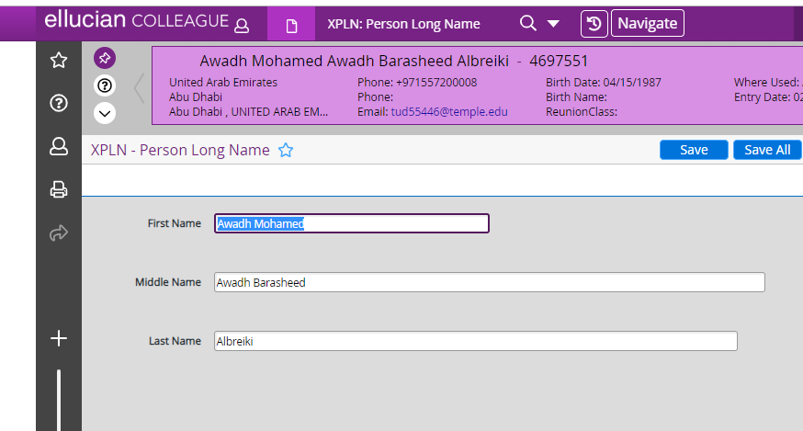

Address
- Student must have a permanent foreign address in ADSU
- Immigration transfer-in students must have both “Permanent Foreign” address, and “US Local” address in ADSU

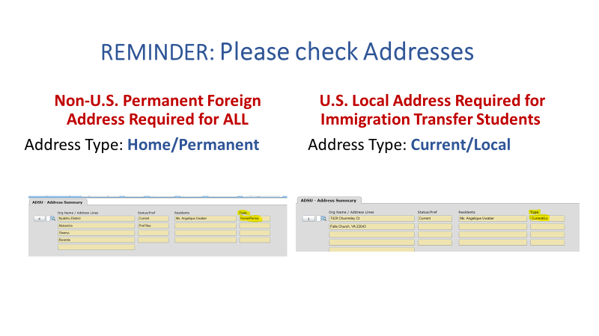

Exchange Agreements, Scholarships, and Merit Awards
- All exchange agreements (MOAs) must be fully executed and unexpired before PIIRF submission. Within the PIIRF, admissions will be asked to input the name of the agreement and the amount in USD that the agreement covers. In the remarks section, admissions should list the amount in USD that the student needs to show once the exchange agreement has been deducted. MOA funding is listed as “Current Sponsor” Funding on the immigration document.
- All AU merit awards must be signed/accepted by the student before PIIRF submission. The amount in USD being given to the student for the first year of studies should be entered into the PIIRF and the fully signed scholarship letter should be uploaded.

Certification of Finances for International Students (CFIS)
- Admission offices must collect a completed CFIS form from students to submit with the PIIRF
- Admission offices can link to ISSS website for the CFIS updated form (and can include this link on their webpages as well)
- The CFIS form must be signed by the student and by all financial sponsors. If the form is submitted with missing information/signatures, ISSS will need to reach out to the student, which will delay the issuance of the immigration document. Electronic signatures may be accepted on the CFIS form, however, a typed name will not be accepted.

Financial Documents
- Admissions must also collect supporting financial documents from the student before submitting the PIIRF.
- Admissions must electronically stamp the financial document with the date that they received it so that ISSS can verify the document was received within 3 months of the date of the financial document. If Admissions does not stamp the receipt date, ISSS will go by the date that the PIIRF was received.
- ISSS cannot issue an I-20 or DS-2019 without receiving a completed CFIS Form along with the financial documents. While it is ISSS’s responsibility to review financial documents to ensure they meet immigration requirements, it is admissions’ responsibility to collect these documents from the student and submit them with the PIIRF.

International Student Cost Guides for Each New Academic Year
The university’s costs for the new academic year are published every year (or sometimes every two years) around March. The International Student Cost Guides are published thereafter.
Admission offices will be asked to review the costs of their programs by ISSS. ISSS will contact each Admission office directly (see Admission Contact list) about special fees associated for special programs such as Kogod MBA, ELTA, SIS Exchange, and Human Rights Hybrid program and other Hybrid LLMs.

The exceptions are Washington Semester and Abroad at AU who provide the cost guides themselves.

Regarding financial documents while the new cost guides are still being developed:

- ISSS will accept financial documents showing sufficient funds to cover the previous academic year’s cost guide if the following conditions are met:
  - The financial documents are dated within three months of submission to AU admissions (ISSS verifies this by the electronic stamps admissions uses upon receipt of the document).
  - The financial documents meet the normal requirements.
- ISSS will notify the student of the new costs of their program of study when any of the following conditions are met:
  - No financial documents are received before the new International Student Cost Guides have been published.
  - The financial documents received from the student are insufficient or not acceptable.

Dependents
International students on an F-1/J-1 visa (primary non-immigrant visa status) can bring their dependents (children and spouse) in F-2/J-2 visa status (as their secondary).
Child: Any biological child (as evidenced by birth certificate), or officially adopted (as evidenced by adoption certificate), under the age of 21 years old
Spouse: A spouse as evidenced by a marriage certificate (same sex marriages will be recognized if the marriage is “recognized in the place of celebration”)
- If student has dependent(s) at the time of PIIRF submission, admissions must submit a separate “add dependent” e-form for each dependent
- Passport for each dependent is required to match the name and bio information
- Email addresses for dependents older than 18 years are required
- City of birth is required for each dependent (this information can be found on the CFIS if it is not on the dependent’s passport)
- Additional funds are needed: $5,500/year for spouse and $4,000/year for each child

Immigration Transfer-In
If admission offices are aware of a student who is transferring in from another U.S. institution, they should ask the student to submit the “transfer-in” e-form in iEagle under the “new student” menu. Transfer-in students must meet all AU admission requirements and submit the same documentation as overseas students.

Please note: ISSS advisors should also frequently check the SEVIS transfer-in list for any students that have been transferred to AU but do not yet have a PIIRF submitted. Toward the end of the cycle, if a PIIRF has still not been submitted for the student, the student should be contacted and told to follow up with their admission office.

3.2 Submitting a PIIRF in iEagle
Sunapsis’ student and departmental user interface at AU is called iEagle and works in conjunction with Colleague (AU’s database) and SEVIS (the U.S. Government Student and Exchange Visitor Information System).

To submit an official request for ISSS to issue an immigration document for an admitted student, the admission office will need to submit the PIIRF e-form in ieagleadmin.american.edu. The PIIRF should only be submitted after all information in the previous section has been collected.

The PIIRF contains information pulled from Colleague that is essential to processing immigration documents (e.g., biographical information, semester admitted, academic degree). It also includes vital information that will help ISSS determine what type of immigration document to issue (e.g., I-20, DS-2019, Transfer I-20), what cost guide amount to use as the base requirement, and if the student is on an exchange agreement or scholarship/merit award.

Accessing iEagle

To use iEagle, admission staff must login to myau.american.edu, and under the “Office Assistant,” click on iEagle. Alternatively, they can access iEagle directly by clicking this link: https://ieagleadmin.american.edu/istart/controllers/admin/login.html

- In order to access iEagle, the admissions staff must be added as a departmental user in iEagle by ISSS’s Sunapsis administrator.
  - Staff can submit requests to be added as a departmental user directly in iEagle
  - Alternatively, the staff can send an email to isss@american.edu with their full name and email address to request access
- Once granted access, a departmental user logs into ieagleadmin.american.edu using their AU username and password.
- Once logged into iEagle, the departmental user should either click on the “New Student” menu to submit a PIIRF for a new student, or the “Change of Academic Level” menu to submit a change of level PIIRF.
- The “Departmental Services” menu can be used to see what PIIRFs have already been submitted by the user/department.
- Admission offices should let ISSS know when individuals are leaving AU so that we can delete their profiles from Sunapsis and when new individuals are hired so that we can make sure they have access to submit PIIRFs.

Submitting PIIRFs for Initial Students

For all initial incoming students (including immigration transfer-ins from another U.S. institution), departmental users should click on the “New Student” menu on the left and then choose the appropriate program.

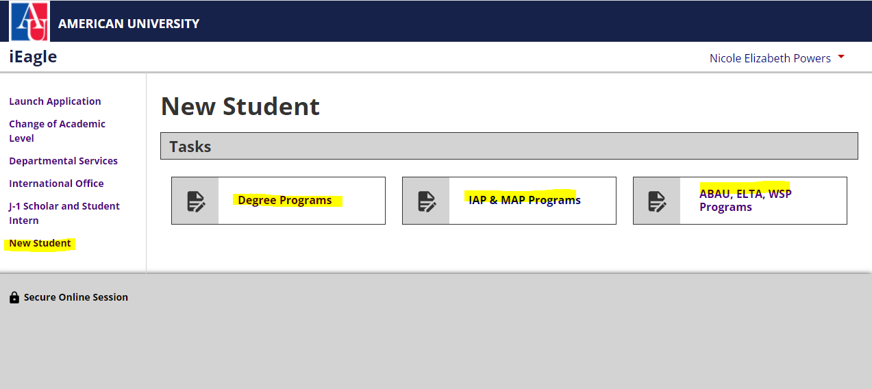

Next, they will type in the student’s University ID and Date of Birth. If an error message appears, there could be a few reasons. First, the user should make sure there was not a typo in either the AU ID or the DOB. Admissions should also ensure that the student’s record was created in Colleague at least 24 hours prior to submitting the PIIRF. If an error message still occurs, ISSS’s Sunapsis administrator should be contacted so they can double check that the datafeed is working.
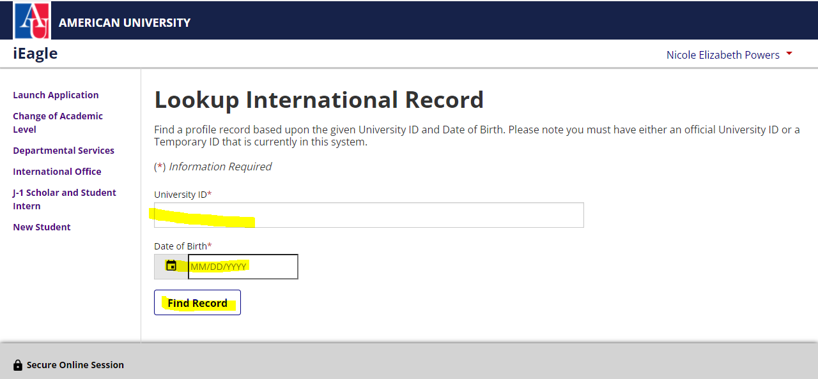

Once the student’s record has been successfully pulled up in iEagle, the departmental user should click on “Personal and Immigration Information Request Form” to submit the PIIRF for the student.

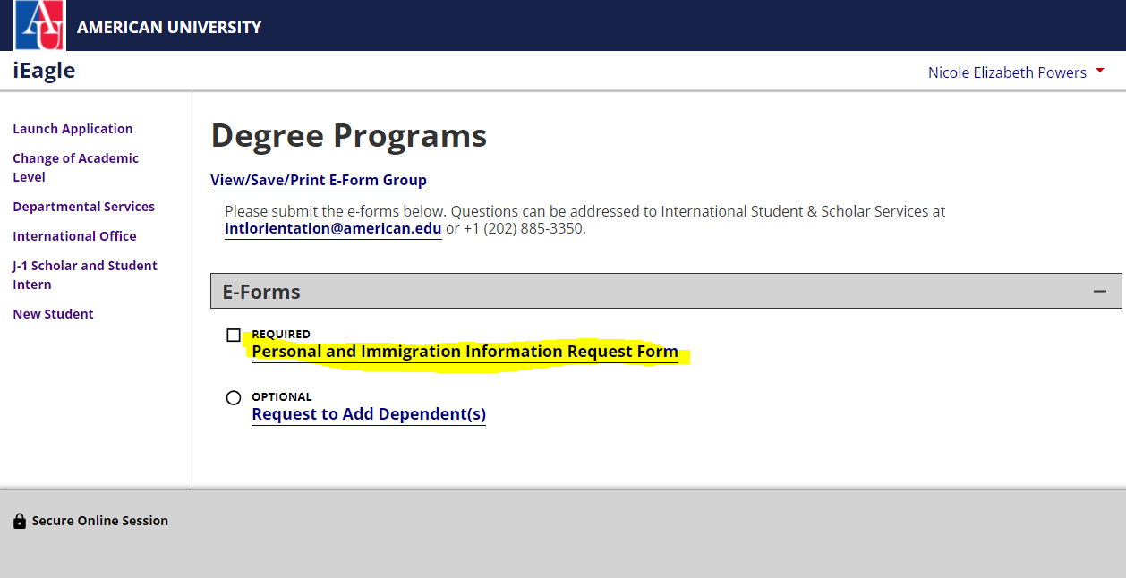

Information the PIIRF will ask for:

- Admitted term should be chosen from the drop-down menu
- Correct program information should be noted (e.g., MS- Finance, LLM in International Legal Studies, etc.)
- Type of immigration document needed should be chosen from the drop-down menu (I-20 or DS-2019)
- If the student is currently enrolled at AU, “yes” should be selected in the relevant question. The form will then direct the user to submit the COL PIIRF instead of the New Student PIIRF
- If the student was previously enrolled at a US institution other than AU, “yes” should be selected and the name of the school and dates of attendance should be entered. This will help ISSS determine whether a transfer-in I-20 is needed.
- The biographical information section will ask for the student’s country of birth, city of birth, foreign phone number, and personal email address. If unknown, this information can be pulled from the CFIS form.
- The Passport and Financial Information section will ask for admissions to upload PDF copies of the student’s passport, CFIS, and financial documents. More spaces are provided if additional uploads are needed
- If the student is receiving a scholarship from AU, “yes” should be selected in the relevant question, and a copy of the signed/accepted scholarship letter should be uploaded
  - The name of the scholarship should also be entered (if applicable)
  - The amount the student is receiving for their first year of studies should also be entered
- The Memorandum of Agreement (MOA) section will ask if the student is coming to AU through an exchange agreement
  - If yes, the name of the agreement should be entered (this is usually entered as “AU Department-Exchange Agreement Institution, e.g., WCL-Nanterre)
  - The amount of program cost the exchange agreement will cover should also be entered. The remaining amount the student needs to prove should also be entered
    - NOTE: the MOA must be valid for the length of the student's program. For instance if a student is coming for Fall 2023, the MOA must be valid through the entire semester. If a student is coming both Fall 2023 and Spring 2024, the MOA must not expire until after Spring 2024 ends.
- For English Proficiency, method of ELP can be selected from the drop-down menu
  - ELP is always required (except for Hybrid Human Rights taught in Spanish)
  - Test scores can be input into colleague or results can be uploaded to the PIIRF
  - If “met-other reason” is selected, the remarks/comments field should be completed to explain how the student met the ELP requirements
- If student has dependents, “yes” should be indicated in the drop-down and then a separate “Request to add dependent(s)” e-form should be submitted by the user for each dependent

After completing all information above, the user can click “submit.”

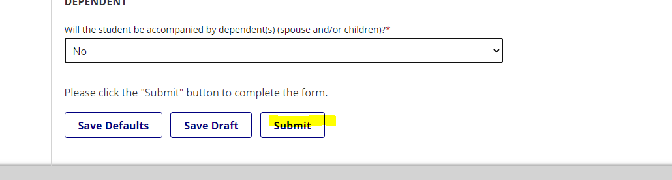

An automatic acknowledgement email is sent out to the department user who has submitted the PIIRF e-form.

Submitting PIIRFs for Change of Level (COL) Students
All COL I-20s must be issued before the end of the add/drop period. Admissions must consider this when submitting COL PIIRFs.

Departmental users should submit the COL IAP & MAP Program PIIRF for the groups below:

- Students progressing within IAP (e.g., from Pre-Sessional to IAP or Pre-Sessional to MAP)

Departmental users should submit the COL Degree Program PIIRF for the groups below:

- Students progressing from IAP & MAP to Degree Programs
- Students progressing from one degree program to another degree program at AU such as from BA to MA or MA to PhD
- Graduate level students who want to change programs

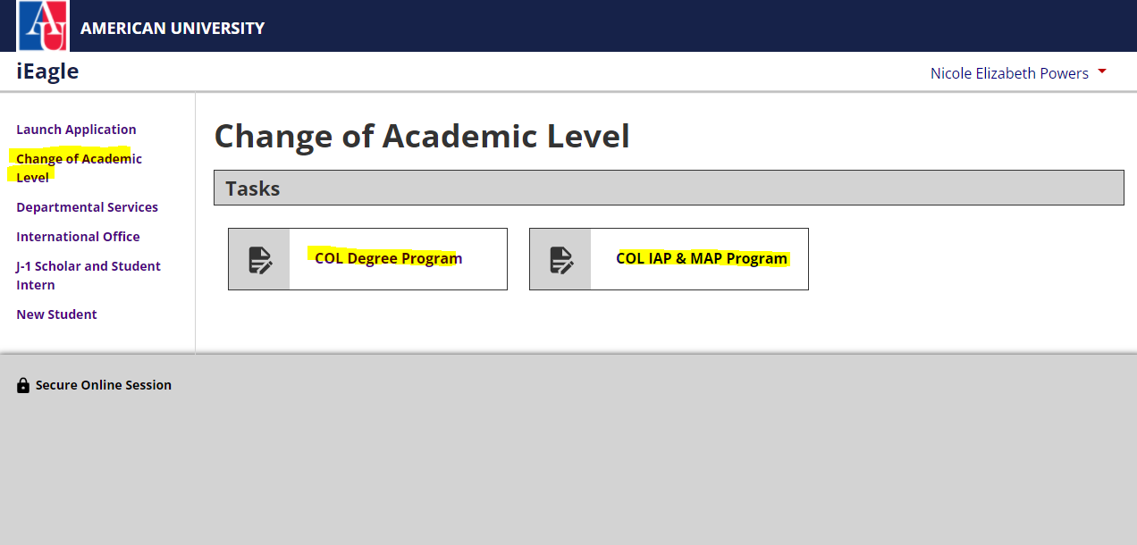

Information the COL IAP & MAP Program PIIRF will ask for:

- Most information is the same as the “new student” PIIRF, however, admission offices should create a new admission record in APPN in colleague for the new program BEFORE submitting the COL PIIRF
- Admitted term for new program should be chosen from drop-down
- Program information should list new program (e.g., IAP, MAP, American Access)
- Visa status should likely be “currently holds F-1 visa”
- Current program and begin and end dates should be listed
- ELP requirement should be “Met Progression Requirements”
Note: Student submits fin docs e-form and we review before the COL's are submitted. Therefore, once the COL PIIRFs are submitted, we have already approved the fin docs e-form so we can just issue the new I-20.

Information the COL Degree Program PIIRF will ask for:

- Most information is the same as the “new student” PIIRF, however, admission offices should create a new admission record in APPN in colleague for the new program BEFORE submitting the COL PIIRF
- Admitted term for new program should be chosen from drop-down
- Program information should list new program (e.g., BA in Computer Science)
- Visa status should likely be “currently holds F-1 visa”
- Current program and begin and end dates should be listed
- Student will submit passport, financial documents, an CFIS for new program to admissions and admissions will upload to PIIRF
- ELP requirement should be “Met Progression Requirements,” “Grad with BA from US institution,” or “Grad with MA from US institution”
- Admissions should indicate whether the student is receiving an AU scholarship for the new program

3.3 I-20/DS-2019 Distribution Policy
Once ISSS creates an immigration document, we will approve the PIIRF, and an automatic email will be sent to the student with the admitting unit copied.

Based on current DHS guidance and current DOS guidance, I-20s and DS-2019s are issued and signed electronically by ISSS and made available for students to download in iEagle. Admission units do not need to mail physical copies of I-20s and DS-2019s.

ISSS will never electronically transmit immigration documents to anyone other than the student themselves via email or through upload to iEagle.

3.4 Changing Majors or Programs

Major Changes in initial status:
- Major changes for UG students can happen only after the student has started the program. NO major changes are allowed when students are in initial status.

Program Changes At The Graduate Level:
- Program changes at the graduate level are not immediate and may only happen if permitted by the Academic Director
- The student must apply for and be admitted to the new program
- The new program must be added to Colleague, and the old one must be closed
- A COL Degree Program PIIRF for the new program must be submitted to ISSS with new financial documents and CFIS form
- Student will receive a new immigration document I-20 and will need to submit immigration registration again
- These changes cannot be processed mid-semester (must occur before the end of add/drop each semester)

3.5 Deadlines for PIIRF Submission
TYPE OF STUDENT | FALL SEMESTER | SPRING SEMESTER
Abroad at AU & Washington Semester | April 15 | November 1
Incoming Students | June 1 | October 15
Immigration Transfer-In Students | July 1 | December 1

The above are considered priority deadlines to give the student the best chance of being able to secure a visa in time to arrive for the semester. PIIRFs can still be accepted after these dates but should be discussed with the ISSS admission team in advance of submission so we can determine the feasibility of each case.

3.6 Communication with Admission Units
Admission unit contact information can be found in the K Drive: K:\ISSS\ADMISSIONS\Directory. This information is updated with any departures/new hires as we hear of them.
ISSS holds two admissions meetings with all admissions staff each year (one before each admission cycle starts) to discuss updates in admission requirements, SEVP updates and guidelines, best practices and lessons learned from each cycle, and identifying needs for training.
The ISSS admission team also offers periodic training to Admission offices and in-depth training for each newly hired admission staff, if requested.
Periodic email reminders and updates are also sent before each admission cycle and after new SEVP guidance or requirements.

Creating Immigration Documents

Incoming PIIRFs will be received for the following types of students:

- Initial attendance – Students who are applying for a visa from overseas.
- Transfer – Students who currently hold a valid F-1 or J-1 visa at another US institution.
- Change of Status – Students on another visa category who are applying to change to F-1 or J-1 status.
- Change of Level – Current students at AU who are completing their program and have been admitted to another program at AU.

PIIRFs for initial attendance and transfer-in students will be submitted under the “New Student” menu in either the “Degree,” “IAP & MAP,” or “ABAU, WSP, ELTA” category.

PIIRFs for Change of Status students may come in one of two different ways:
- A new admit that will change to F-1 or J-1 to start their program at AU will be submitted by the admission unit in the “New Student” menu
- A continuing student that would like to change status mid-program can submit the request themselves using the “Request I-20” form under the “International Office” menu in iEagle. Students returning from a Temporary Leave of Absence also use the “Request I-20” e-form to request a new I-20 when they are ready to return to AU.

PIIRFs for Change of Level students will be submitted under the “Change of Academic Level” menu in either the “IAP” or “Degree” category.

4.1 Initial Immigration Documents
Evaluating and Processing PIIRFs for Initial Attendance
- Access the Checklist
  - Once logged into Sunapsis, click on “Checklist Management” under “Workflow Management”
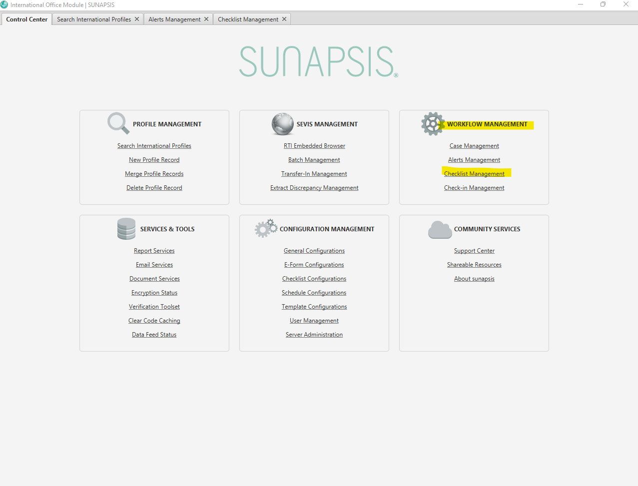
  - The checklists for new students will be differentiated by student group and by checklist stage.
    - For incoming degree-seeking students, the checklist to review is “New Student—Degree Programs – PIIRF Submitted” stage
    - For incoming IAP & MAP students, the checklist to review is “New Student – IAP & MAP Programs – PIIRF Submitted” stage
    - For incoming ABAU, ELTA, and WSP students, the checklist to review is “New Student – ABAU, ELTA, and WSP students – PIIRF Submitted” stage
  - After double clicking on the checklist you are reviewing, submitted PIIRFs will be indicated with a red exclamation mark
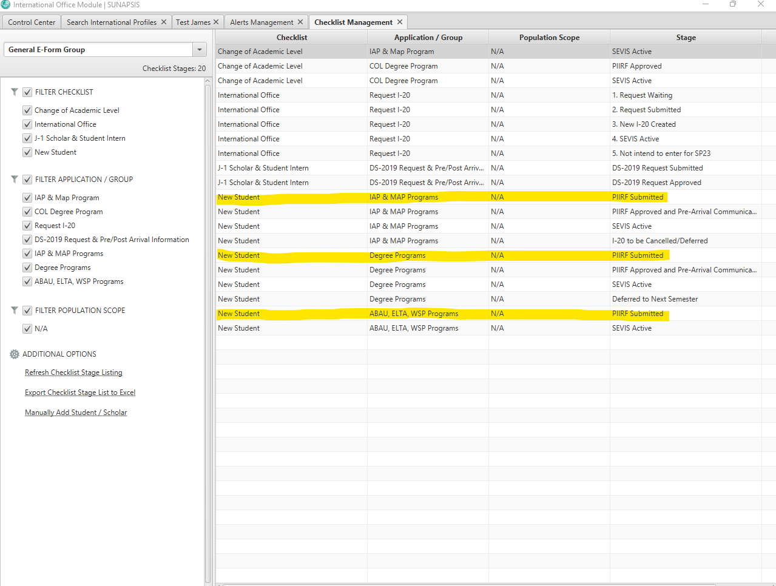

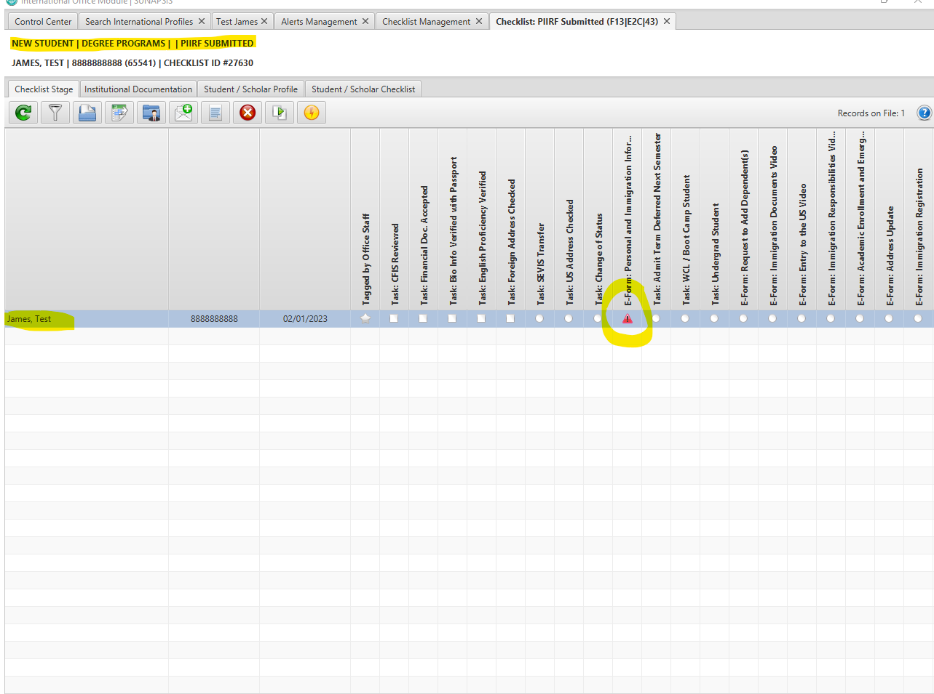
- Evaluate Student PIIRF
  - After double clicking the student’s name, their Sunapsis profile will open
  - Click on Workflow Management,” and then double click the PIIRF e-form (Degree Programs, IAP & MAP Programs, etc.)
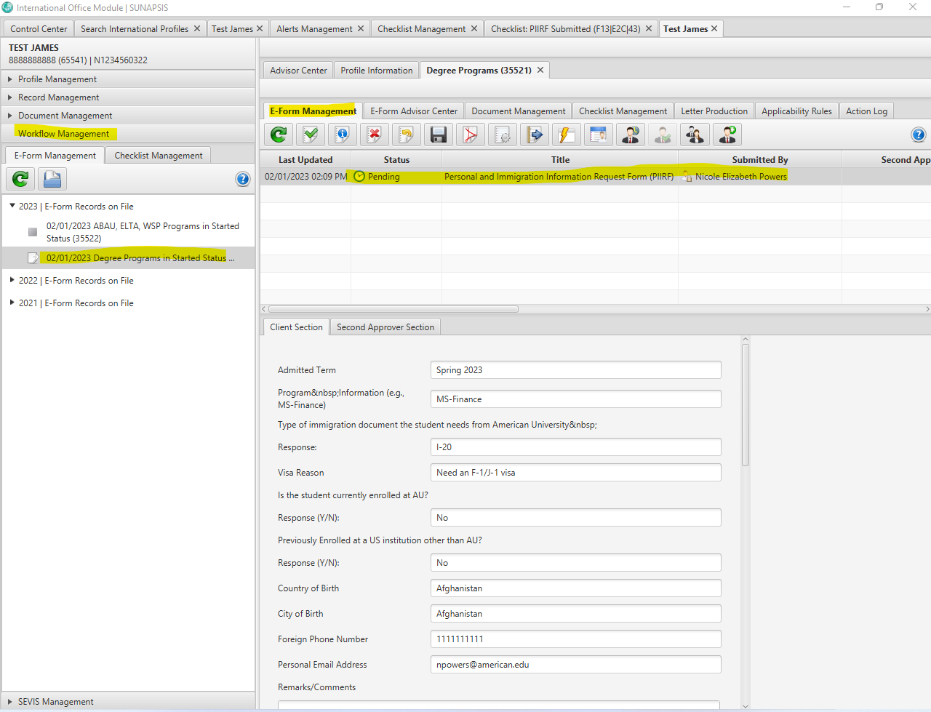
  - Review the information in the PIIRF to understand which school and program the student is admitted to and which immigration document they are requesting
    - Verify that the student’s Immigration Status in Sunapsis corresponds with the requested immigration document in the PIIRF (Record Management – Biographical Information – Core Biographical)
    - Verify that there is an admission record in Sunapsis that corresponds with the admitted term and program listed in the PIIRF (Record Management – Student Admission Information – Admission Information)
    - Verify that there is a program record that matches the program in the PIIRF (Record Management – Student Academic Program Information – Program Information)
    - If there are any discrepancies between the PIIRF and this information in Sunapsis, the admission unit may need to be contacted for clarification
  - Review the English Language Proficiency in the PIIRF and ensure that test scores are either uploaded as a PDF or stored in Student Admission Information – English Proficiency Scores. If “Met-Other Reason” is listed, the reason should be documented in the remarks section. For more information on acceptable proof of English Proficiency, please see section 2.6 of this manual.
  - Review the foreign address and U.S. address (if a transfer-in). These are found in Record Management – Biographical Information – Addresses

- Review Supporting Documents
  - Documents can be opened directly within the PIIRF e-form and are also stored in “Document Management”

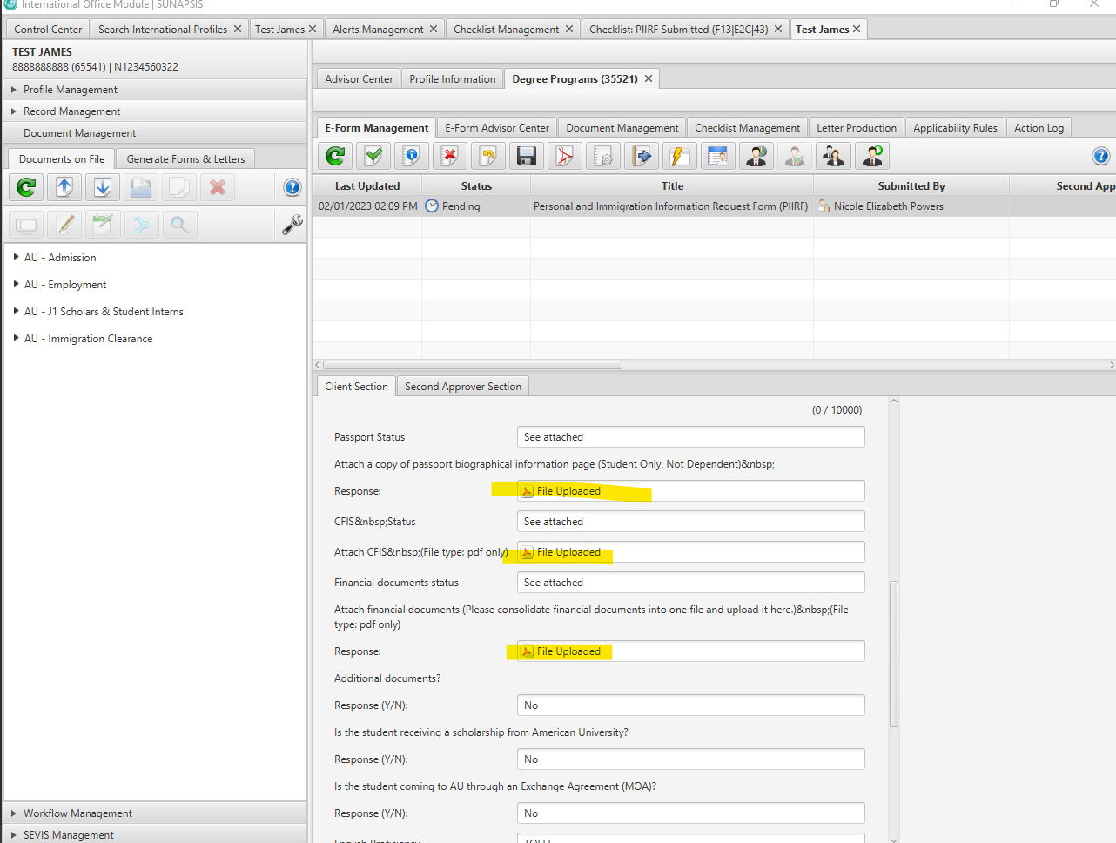

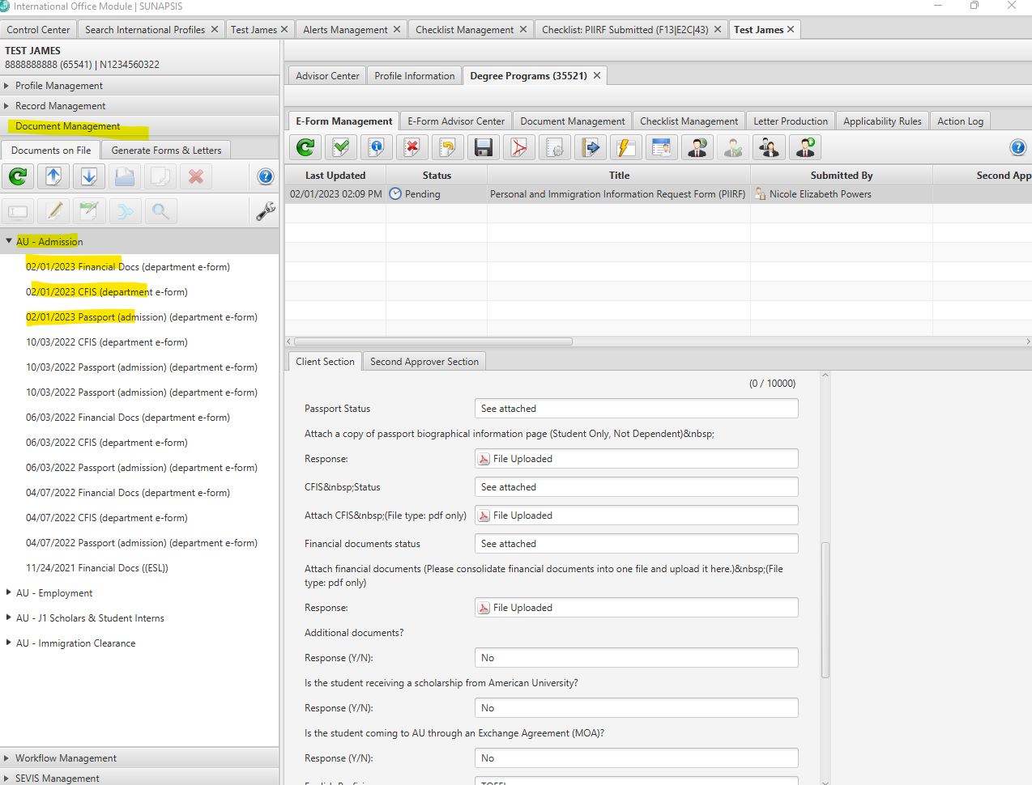

    - First, check that the passport MRZ name matches the name in the student’s Sunapsis profile (Record Management – Name Management), the Date of Birth matches the DOB in Sunapsis (Record Management – Core Biographical), and the Country of Citizenship matches in Sunapsis (Record Management – Core Biographical). City of birth is listed on the PIIRF. Double check that it matches the passport if it appears on the passport, or what the student entered in their CFIS form.
    - Next, open the student’s CFIS form and review it according to the standards listed in Section 2.5 of this manual
    - Finally, review the student’s financial documentation according to the standards in section 2.5 of this manual
    - Do any XE conversions and upload a screenshot to Document Management – AU – Admission – Currency Conversion. You can upload files by clicking on the “up” arrow icon, finding the document on your computer, and saving it to the correct category (in this case it will go in AU-Admissions)
    - If the student is receiving an AU scholarship, please review the guidance for this documentation in section 2.5 of this manual. If the student is a J-1 exchange student coming to AU through an MOA, please review section 2.7 of this manual before issuing an immigration document.

- Approve Checklist Tasks or Follow-Up with Student
  - If everything looks good, the checklist tasks should be approved by right clicking on the corresponding task. Instructions for issuing the I-20 and approving the e-form can be found in the next section.
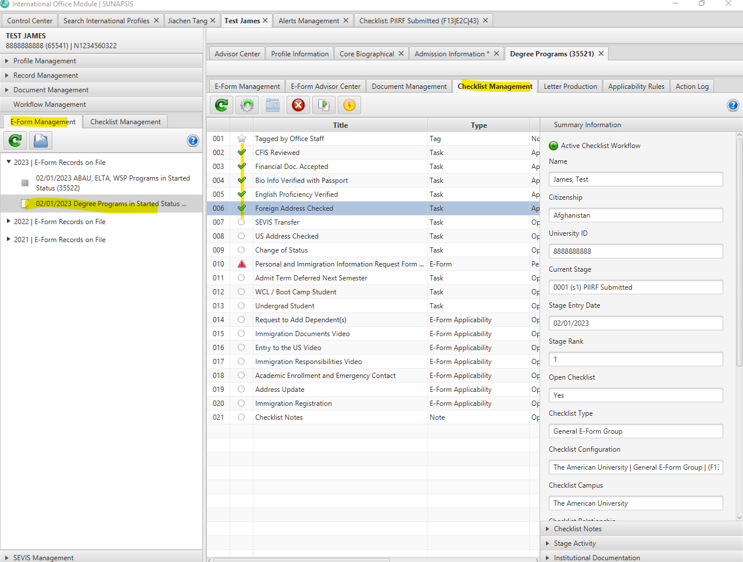
  - If there are issues with documents that the student has provided, send an email to the student through Sunapsis. The email should be sent from isssdocuments@american.edu and should be sent to both the student’s personal and AU email. The email templates for ISSS admissions are saved in the K-drive in the “Admissions” folder. Typically, admission units like to be copied on these emails so that they keep track of their PIIRFs. Checklist tasks that need follow-up should be marked on the checklists as “follow-up” status. If the student is ABAU/WSP/IAP, follow up with the contact through the appropriate communication platform (email or Smartsheet) regarding need for more or different documentation. Do not email the student directly in these cases.
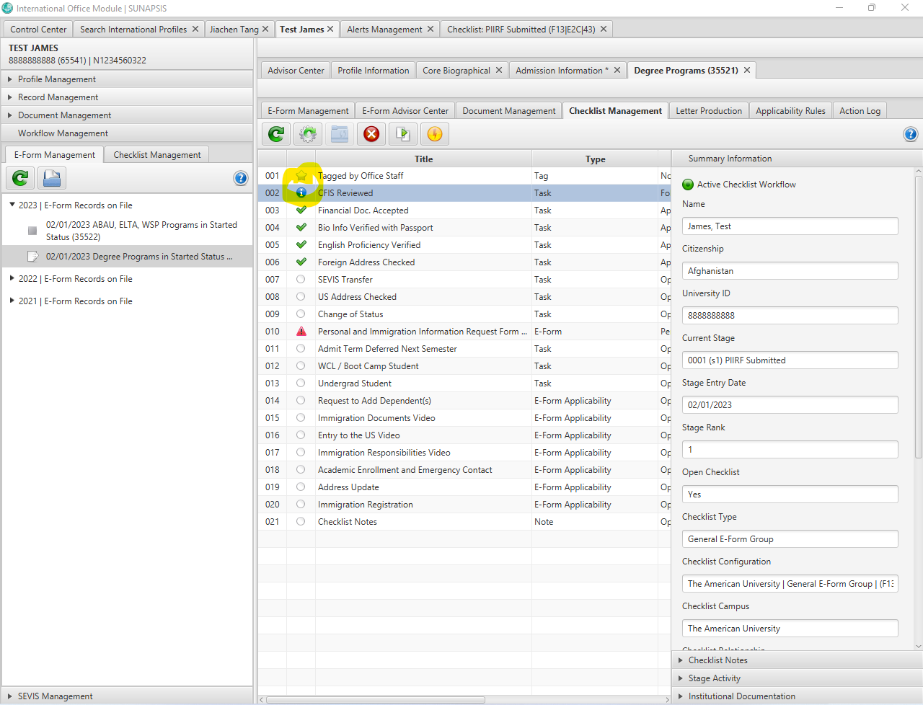

Steps to Issue the Immigration Document
- Apply the template
  - Once everything looks good, go back to the e-form and click the blue arrow to apply the template that corresponds to the student’s program. Templates must be updated once Program Dates (and program costs, if fall) are confirmed for the upcoming year. If any changes are needed to the templates, contact the Immigration Data Manager for ISSS.

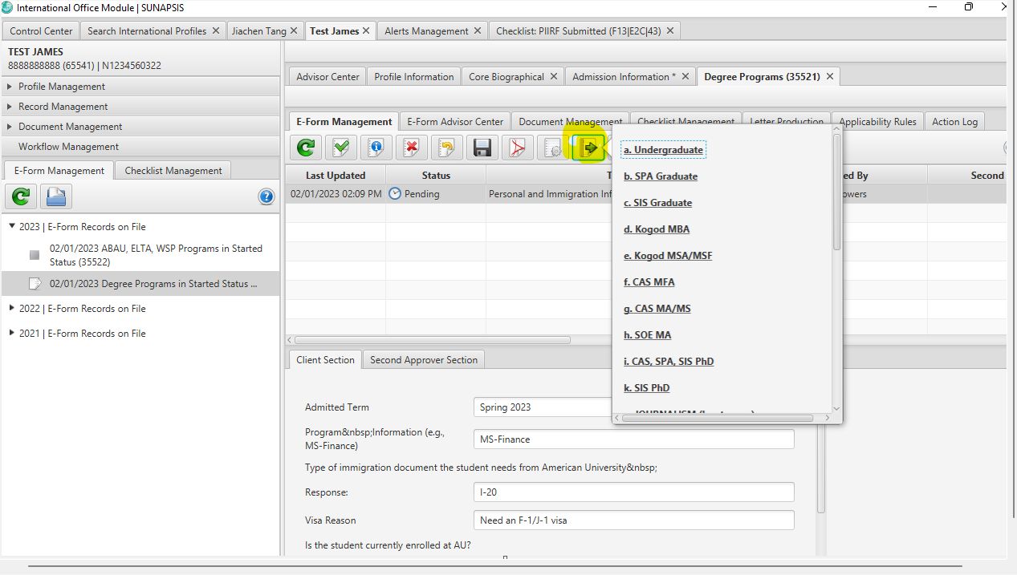

  - The template will populate the Extended Biographical screen with city of birth and country of birth
  - For F-1 students:
    - The I-20 Program Information Screen will populate SEVIS status as “Initial,” the Education Level, Program Dates, and English Requirements Met. ISSS Advisors will need to copy and paste the CIP code from the Admission record in Sunapsis to the “Primary Major” field (this CIP code should match the academic program code in the Program Information screen. If it doesn’t, ISSS may need to follow up with admissions to understand which program the student is pursuing).
    - The I-20 Financial Information screen will populate the Academic Term, Expenses, and Remarks. ISSS Advisors will need to fill in the Funding section according to the documentation provided by the student. If there are multiple funding sources, list them in the following order: AU Scholarship, Exchange Agreement, Personal Scholarship, Government, Personal, Family, and Sponsor.
  - For J-1 Students:
    - The DS-2019 Program Information screen will populate SEVIS status as “initial,” Position as either “University Graduate Students” or “University Undergraduate Students,” Category as “Student Masters,” “Student Doctorate,” “Student Bachelors,” or “Student Non-Degree,” Subject Field Remarks as “Study at Grad/Undergrad Level,” and the Program Start and End Dates.
    - The Site of Activity Information screen will populate AU as the site name along with “yes” as active site and AU’s address.
    - ISSS advisors will need to open the DS-2019 Financial Information screen and fill in the funding according to the documentation that the student provided. If there are multiple funding sources, list them in the following order: AU Scholarship, Exchange Agreement, Personal Scholarship, Government, Personal, Family, and Sponsor.

Please note: Advisors should always ensure that the template is populating correct information by verifying with the Program Start and End Dates document and Cost Guides excel located in the K drive. If any changes are needed to the templates, contact the Immigration Data Manger for ISSS.

- Create Immigration Document in SEVIS
  - Launch the RTI Embedded Browser from the Sunapsis home screen
  - Login to SEVIS
  - Select Listing of Schools for F-1
  - Select Listing of Programs for J-1
  - Choose “New Student” or “New Exchange Visitor” and enter AU ID number when prompted.
  - Go through each page and hit “Populate Field” icon on bottom right of screen. This will pull in the template information from Sunapsis.
  - Once all screens are complete, click print final I-20/DS-2019 and the PDF will generate.
  - I-20s can be signed with DSO’s electronic signature in Adobe and saved as a PDF. DS-2019s must be signed with the ARO’s digital signature and should be configured using the “certificates” function in Adobe. For help with setting up a digital signature, please contact ISSS’s Immigration Data Manager.

- Make Immigration Document Available to Student
  - Once the document has been signed by the DSO/ARO, the document must be uploaded to Sunapsis in document management under the SEVIS Documents – Display Online category. This will allow the student to be able to access it from their pre-arrival checklist in iEagle.
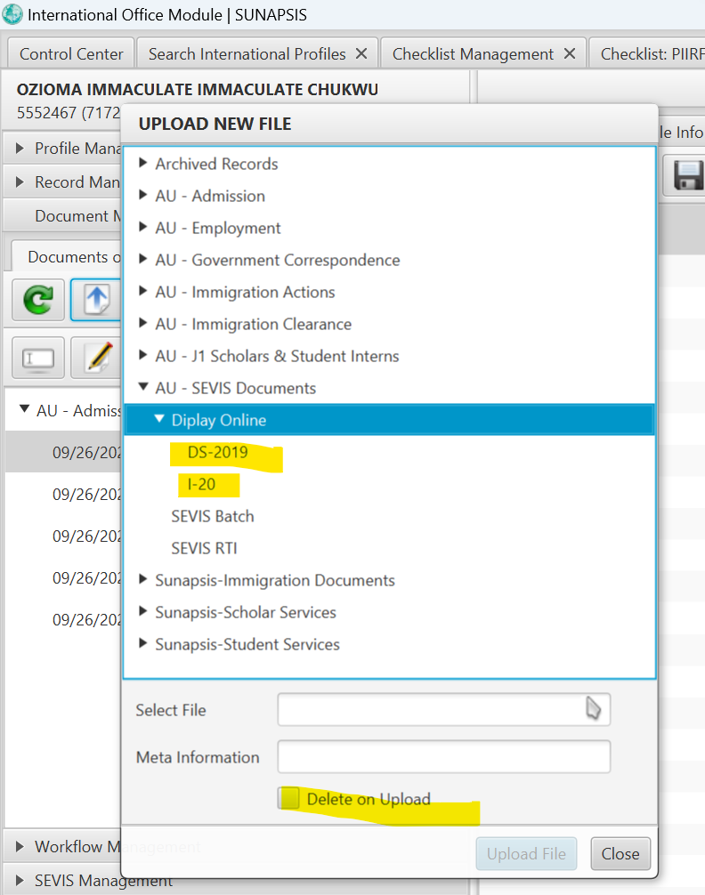
Student will see:
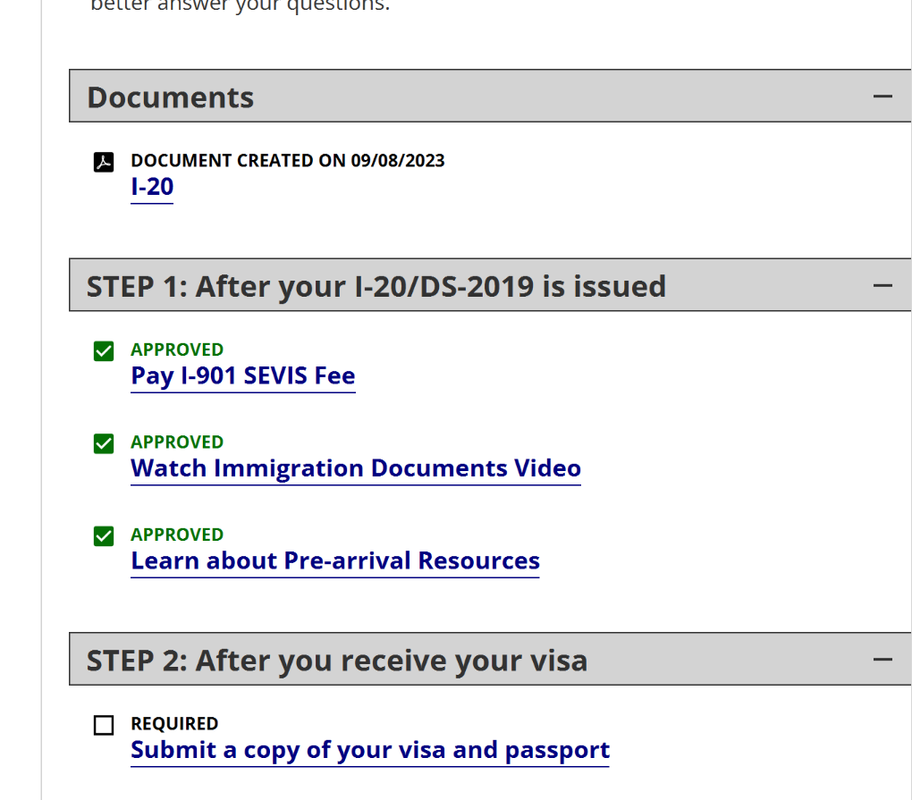
  - Once I-20/DS-2019 has been uploaded, the ISSS advisor should approve the PIIRF e-form and an email template will populate to notify the student that their immigration document has been created and will include instructions to download it. The PIIRF submitter should be copied on this email.
Initial students I-20/DS-2019 Flowchart
Student Application
Admission Decision
Student Accepts
- Student Deposits
- Admission unit submits PIIRF

Student Declines
ISSS Evaluates PIIRF and included documents
END
Issue with included documents
All documents look good
Student sends new documents
Student requests deferral or withdraws application and PIIRF is cancelled
ISSS emails student
PIIRF e-form is approved and checklist tasks have been updated
I-20/DS-2019 made available for download in iEagle

Sending Emails to Students in Sunapsis
When a follow-up email needs to be sent to a student, the email function in Sunapsis should be used. The email should be sent to both the student’s AU and personal email and should be sent from isssdocuments@american.edu. Email templates are saved in the K-Drive in the Admissions folder and can be copy and pasted into the email body. Types of email templates are described below.
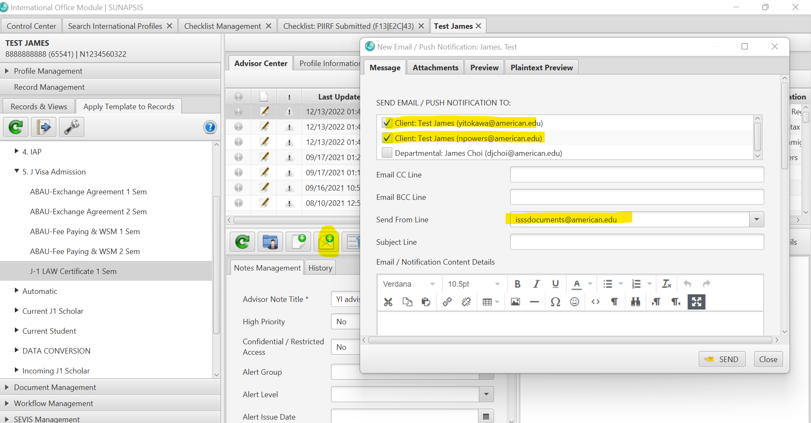

Cost of Attendance
To be used when:
- A student is requesting an explanation on the costs listed in the cost guide.
- A student is inquiring about on-campus employment as a source of funds to cover expenses.

- If this email is used, choose the “follow-up” option in the financial documents task in the checklist and enter notes in Sunapsis. The checklist task is approved when ISSS receives acceptable documents.

Missing Financial Document(s)
To be used when no financial documents have been received from the student.

- If this email is used, choose the “follow-up” option in the financial documents task in the checklist and enter notes in Sunapsis. The checklist task is approved when ISSS receives acceptable documents.

Financial Document Problem
To be used when:
- Incomplete CFIS form;
- Insufficient funds;
- Financial document(s) older than 3 months;
- Missing supporting document(s) e.g., form I-134 and/or letter from a sponsor;
- Submitted document(s) lack contact information of the institution issuing the financial document(s), i.e., date, bank’s name, address, and phone number; and
- Document(s) do not specify a currency

- If this email is used, choose the “follow-up” option in the financial documents task and/or the CFIS task in the checklist and enter notes in Sunapsis. The checklist task is approved when we have received acceptable documents.

Change of Status (COS) Request
Changing Visa Status to F-1: Changing status within the US generally takes 6-8 months. Individuals who are NOT in F status and would like to change their visa status outside the United States should apply for an F-1 visa at a U.S. Consulate or Embassy while abroad. This email should be used for individuals who are NOT in F status and are planning to change their status to F-1 inside the United States.

- If this email is used, indicate this in the checklist task called “Change of status request” and enter notes in the advising history. The ISSS advisor in charge of COS students keeps the information for each student in their calendar and updates the date of the I-20 each month, until COS is approved.

Immigration Transfer Form Request for F-1 Students
To be used when:
- A student is currently studying or is on OPT at an institution in the United States and would like to enroll at AU.
  - The student is required to complete an immigration Transfer-in form. The email explains the immigration transfer procedure and gives the instructions on how to submit the transfer-in e-form

- If this email is used, select the follow up on the transfer task of the checklist and enter notes in Sunapsis.

Note: For multiple problems, only send one email listing all the problems rather than sending multiple template emails. Appropriate checklist tasks should also be marked as “follow-up.”

Exception: Do not send any emails to the Abroad at AU, Washington Semester, or IAP students directly. Instead, notify the Abroad at AU/WSP/IAP office directly. However, making notes in Sunapsis and marking tasks in the checklist still apply.

4.2 Immigration Transfer-In
International students currently in active F-1 status can transfer their immigration record to another US institution if they meet these requirements:
- Student must be in active immigration status and admitted to a new program at another institution and have the intention to transfer.
- Student is requesting to be transferred to another institution within 60 days from the end of classes/program or OPT end date at the current institution.
- The new program should start within 5 months from the end of the current program.
- Please note: AU does not accept F-1 records in terminated status
Immigration Transfer-In Process
- Student is Admitted to AU
  - An immigration transfer-in student must follow the same admission procedures as a new, initial student
  - After the student has deposited, they will send the normal documents to their admission office (CFIS, financial documents, passport) and admissions will submit a PIIRF to ISSS
    - On the CFIS, a transfer-in student should select the “I am currently in the US and intend to transfer my status to AU” so that the ISSS advisor knows to follow-up if the transfer-in form has not been submitted

- Student submits Transfer-In Form
  - A transfer-in student should work with their current DSO to decide on a SEVIS release date to AU
    - When student is transferred from their current institution (school A) to American University (School B), the SEVIS number remains the same and “active” in the immigration system.
    - If students are on OPT, they are not able to work after the release date. Therefore, students should plan to stop working at least one day before their release date.
    - Students can remain in the U.S. between programs even if their visa has expired, as long as all the above conditions are met.
    - If students plan to travel outside U.S., and their visa expires in the future, their visa remains valid even if the visa is issued for the previous institution. Student must receive the I-20 from AU and have a valid visa with expiration in the future to re-enter the U.S.
  - The student submits the transfer-in e-form in iEagle
    - Student should login to ieagle.american.edu
    - Student clicks “F-1 Transfer-in form” located under the “New Student” menu
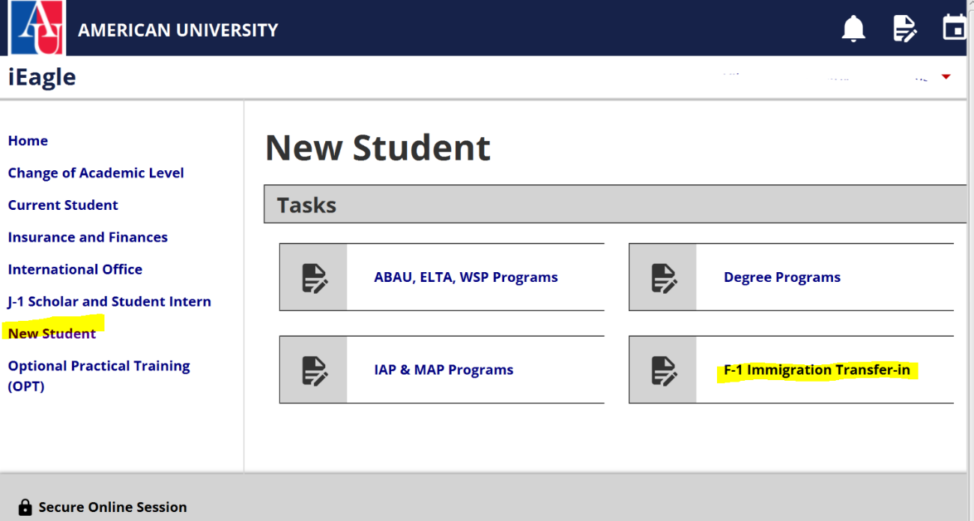
    - The student completes their portion of the form, then inputs the name and email of their current DSO. The form will be routed to the DSO for confirmation of the SEVIS release date

- Transfer-in I-20 is created
  - Review the PIIRF and follow-up on any documents issues
  - Review the Transfer-In e-form and approve it.
    - Email template will populate confirming release date and that once we receive request from admissions (if we haven’t already), we will create the new I-20 within 3-5 days after the release date. This template can be edited according to each student’s current stage in the process.
    - Make note of the SEVIS release date in the student’s Sunapsis profile
  - To find the list of transfer-in students in SEVIS:
    - Launch and login to SEVIS RTI embedded browser
    - Click “listing of schools”
    - Click the “Student Lists” tab at the top of the page
    - Select “Student Transferring In”
      - Pay attention to the “Release Date.” ISSS can create a transfer-in I-20 only on or after the release date
      - If a student is on the list that you do not have a PIIRF for, contact the appropriate admissions office to ensure they were admitted and a PIIRF is submitted
      - If you cannot find the student on the transfer-in list but they’ve had a PIIRF submitted, the student must follow-up with their current school to ensure their F-1 record is released.
  - Click on the student you’d like to create an I-20 for and verify the release date has arrived
  - Enter the University ID number in the “Identify International Record” pop-up to make a connection between SEVIS and Sunapsis to create a student record.
  - To verify the connection has been made between Sunapsis and SEVIS, look at the lower left corner of the screen to see a green circle and the student’s name.
  - Once verified, click “Create I-20” located at the left side of the student’s SEVIS record screen.
  - Go through each screen and use the “populate fields” button to auto-fill information from Sunapsis
  - Click Print I-20 and make available for student in iEagle
  - Approve the PIIRF in Sunapsis and send auto-populated email
Please note: J-1 students’ transfer-in process is slightly different and must be closely coordinated between AROs. A potential J-1 transfer-in must complete the paper transfer-in form located here: K:\ISSS\J-1 Program\J-1 Forms\Transfer. Any questions should be sent to J1ev@american.edu.

Transfer-In Special Cases (review NAFSA Manual 3.G.5 for more information)
Case 1: Student has been released from school A to school B (AU) with a release date more than 5 months from the new program start date at school B
School B will have to issue an initial I-20.
If the release date is in the future, need to ask school A to cancel the transfer. If after the release date, call SEVIS helpdesk to send back the record to school A.
Transferring a SEVIS record from school A to school B
1. Student must have the intent to transfer.
2. Student must maintain status at his or her school. A terminated record can be transferred out, however the other school needs to apply for reinstatement (an initial I-20 is recommended).
3. Student must be admitted to school B.
4. Record must be transferred out within 60 days of the program end date or OPT completion.
5. The start date at school B should be less than 5 months from the completion date at school A.

Case 2: Student has been released from school A to school B and has decided to be transferred to school C.
Before the release date the DSO at school A should cancel the transfer to school B, and transfer out to school C.
If the transfer release date has passed, the PDSO at School B should use the Transfer Out correction to transfer the record to School C. If the correction is not an option, the PDSO should create a dummy record, activate in the same day and transfer out.
Case 3: Student has been transferred from school A to school B. School B has issued the “Transfer pending I-20” and student has decided to be transferred to school C before classes begin (less than 30 days before classes begin).
Student needs to complete immigration registration at School B and record will need to be activated.
Record will be transferred out to School C when it is active.
Case 4: Student is admitted to AU, record was transferred from school A to AU (school B). Student decided not to attend AU (school B) in Fall and will attend AU in Spring semester.
Release date has passed. Work with SEVIS helpdesk to send the record as “completed” back to school A.
Will issue initial I-20 for Spring semester
I-20 will typically be issued within 3-5 business days from the release date.
I-20 that is showing “pending transfer from institution A” doesn’t need a travel signature. When student completes immigration registration, we will print a “continuing attendance” I-20, which will then need a travel signature.

4.3 Change of Level (COL)

4.2 Change of Academic Level
A Change of Academic Level (COL) I-20 is created when a student is moving to a new level of study or beginning a new program at AU (e.g., from a bachelor’s program to a master’s program or from IAP to bachelor’s, etc.).
Steps to create a COL I-20
- Admissions submits a COL PIIRF

  - Receive COL PIIRF from new program admissions office and review according to regular admissions standards (section 2.5 of this manual)
    - Generally, the student’s biographical information should be ok since they already have an I-20 from AU, but double check the passport in case
    - Review new CFIS form and financial documents (IAP students will submit these through the “financial documents” e-form, whereas regular degree COLs will have them uploaded by admissions as part of the PIIRF)
    - ELP is not needed since the student has already been admitted to AU with ELP documented
    - Ensure there is an admission record for the new program in Record Management Student Admission Information Admission Information (if not, ask Admissions to add in Colleague)
  - After everything looks good:
    - Go to record management I-20 Program Information
    - Click the “Duplicate Record” Icon
      - Change SEVIS status to “initial” and education level to new level
      - Copy CIP code from Record Management Program Information and paste into “Primary Major”
      - Update Program Start and End Date and Initial Session Start Date according to Program Dates chart
      - Keep English Required and Requirements Met checked
      - Save
    - Go to record management I-20 Financial Information
    - Click the “Duplicate Record” Icon
      - Change Academic Term if necessary
      - Update Expenses section according to Cost Guide excel
      - Update Funding section according to student’s funding
      - Copy and paste appropriate remark from remarks document located here: K:\ISSS\ADMISSIONS\I-20 REMARKS
      - Save

- 2. Use RTI to create a change of level I-20

- Open RTI Embedded browser and log in SEVIS.
- click the “Go to SEVIS record” button in the student’s profile window.
- Go to Change of Education Level under the Actions in the SEVIS record.
- Click “Populate Fields” in the lower right corner of the page to populate student’s Program information in the SEVIS page.
- Once you have clicked the Populate Fields button, “Select Record” box will pop up.
- Select the new program record on the “Select Record” pop-up, and click OK. This pop-up screen is asking which record the data should be applied to from the I-20 program information page in Sunapsis to SEVIS.
- Double check whether the information that has been populated for the student is correct, then click Submit at the bottom of the page.
- Click Print I-20.
- Click “View Record”
- Click “Return to Search Results” at the top of the page.
- Check whether the new initial SEVIS record has been created.

- Shorten Program End Date

- On the Active SEVIS program record, click on “Shorten Program” under Actions at the left-hand side of the SEVIS student screen.
- Update the current program’s end date
- Click “Shorten Program” at the bottom of the page.
- On the “Select Record” pop-up, select the Active program and click “OK”.
- Click “Return to View Record”

Change of Level Flowchart
RTI or Batch COL I-20

Shorten program on Active record if student has graduated – this should come first before RTI COL – RTI Shorten Active to match current student team dates

Approve PIIRF e-form and make I-20 ready for download
Receive COL PIIRF & supporting documents from admitting unit

After new semester begins:
Student completes immigration registration
In SEVIS, register student’s “Initial” record

Student’s old “active” record is automatically changed to “inactive/deactivated”

Student’s new “initial” record is automatically changed to “active”

Change of Level Special Cases:
ISSS contacts student to pick up I-20 from ISSS office (Before student leaves) – we email them the download link
Student signs certification on page 1 of the COL I-20, which becomes student’s new I-20.
Student will have 2 records in SEVIS:
- Active record: will complete automatically 30 days after graduation.
- Initial record: doesn’t need a travel signature. Student can stay in US (work on campus) or enter any time before the start date. COL has same regulations as the “transfer procedures”.

ISSS receives PIIRF and financial documents from admitting unit after decision.

ISSS issues the COL I-20 within 60 days of the grace period. COL I-20 (could be issued before completing the current program).

Student is admitted to the new program of study for Fall

Case1: Student is graduating in May and I-20 is ending in May.

Case3: Student’s I-20 is ending in May, but still need to take a summer class to graduate

Case2: Student is graduating in August and I-20 ending in August or after.

ISSS receives PIIRF and financial documents from admitting unit after decision.

If student is traveling before summer classes end, ISSS needs to sign the active I-20 for travel. (ISSS continues to update Active record as necessary).

I-20 completes in August, the active record will complete automatically.
I-20 end date is in the future, will shorten and complete the active program.

If student decides to travel, must enter back with the COL I-20 but does not need a travel signature.
1. Must come to attention of ISSS.
2. Current program I-20 needs to be extended.
3. Active program’s I-20 needs to be updated with travel signature as necessary if student plans to travel for vacation before summer class ends.
4. Will issue a COL I-20 at the end of the summer class.
ISSS issues the COL I-20 after completion of Summer classes and contacts student for pick up. For now, they can get itelectonically

*COL I-20 is issued before student finds out they could not graduate.
ISSS needs to cancel the COL I-20.
The cancellation can happen only by going back to the active record. In the “menu”, choose “cancel change of Education Level” link to deactivate the COL.
After the new semester begins student must complete immigration registration and we will activate the new initial record. No continued attendance I-20 is needed.

4.4 Dual Degrees
WCL, SIS and SPA Dual Degree Programs:
JD/MA, LLM/MIS, JD/MPA or MPP, LLM/MPA or MPP

For students who apply and are admitted to the dual degree at the time of initial application:

1.The school where the student is going to start the program will make a note in the comments
field of the PIIRF that the student has been admitted to a dual degree program.

2. ISSS office will issue an I-20 with both programs indicated in the I-20.

3.The dual degree is indicated in the I-20 remarks.

4.The length of the program will be as below:

- For the LLM Programs this will mean issuing an I-20 for the entire length of the dual degree program. (Combining both programs).
- Students enrolled in the LLM program will graduate from both programs once all courses and requirements are completed.

- For the JD programs, we will shorten the I-20 for purposes of the bar exam and the I-20 for that program will end.
- Around 6 months prior to the completion of the first program, student will work with the second degree program to request a new COL I-20.

For students who apply and are admitted for the dual degree after they've already enrolled in the first degree of their dual program:

- 2-3 months before completion of the first program, the second program admission office will work with student to obtain a second I-20 (change of level).
- Student will need to submit new CFIS form and financial documents to meet the financial obligation for the second degree program to the admission office.
- COL PIIRF will need to be submitted by the admission unit of the new degree program.
- ISSS will issue a COL I-20.

WCL and Kogod Dual Degree Programs:
JD/MBA and LLM/MBA

For students who are admitted to the dual degree at the time of initial application

1. Dual degree students between the Law School and Kogod are not permitted to graduate until all courses and requirements for both programs have been completed.

2. The school where the student is going to start the program will make a note in the comments field of the PIIRF that the student is applying to a dual degree program.

3. The I-20 will be issued for the entire length of the program.

4.Both program CIP codes are included in the I-20.

5.The dual degree is indicated at the I-20 remarks.

- For the JD program, student is first enrolled as a 1L JD student and completes the first year of law school. They then move to an intensive MBA year at Kogod, then return in years 3 and 4 to complete their JD requirements. However, this coming fall semester we have a student who starts the program with the MBA confirmed with Kogod Advisor.

- For the LLM program, student is first enrolled in a full year of LLM studies and then completes an intensive year of MBA studies.

For students who apply for the dual degree after they've already enrolled in the first degree program:

- 2-3 months before completion of the first program, the second program admission office will work with student to obtain a second I-20 (change of level).
- Student will need to submit new CFIS form and financial document to meet the financial obligation for the second degree program to the admission office.
- COL PIIRF will need to be submitted by the admission unit of the new degree program.
- ISSS will issue a COL I-20.

Important notes:

1. Admission unit should include language in the online application and/or admissions letter urging students to check in with the second school for the second I-20 about 6 months before they graduate from the first program.
2. The second program should reach out to these students to follow up.
3. Have academic advisors alert admissions offices if an international dual degree student has dropped out of the dual degree after admission.

Note: This document was created based on the ISSS Admission meeting with GRADUATE Admission offices (KOGOD, SIS, WCL LLM and WCL JD)
Last Updated: 06/04/2021 by Mira Hoxha

4.5 Change of Status (COS)
Students enrolled at AU in a valid nonimmigrant status can obtain F-1 status in one of two ways: by traveling abroad or by applying to U.S. Citizenship and Immigration Services (USCIS) in the United States.
Regardless of the way chosen, student must:
- First obtain an initial I-20 from American University
  - If the student has already been admitted and enrolled at AU under a different status, they can request the I-20 by submitting the Request I-20 e-form under International Office, available in international student portal iEagle.
    - In this case, after the Request I-20 e-form is reviewed and approved, the student will need to be removed from the Request I-20 checklist and added to the “New Student – Degree” checklist in the “PIIRF Approved” stage. This is to ensure the student will receive pre-arrival information from ISSS.
  - If the student is a new admit who had not yet enrolled at AU, the admission office for that student should submit a PIIRF
- Student will need to submit required documents (e.g.: new financial documents, new CFIS, and passport bio page.
- Student will need to pay the I-901 SEVIS fee online and print the receipt: www.fmjfee.com .
- Once the initial I-20 is issued and the SEVIS fee is paid, student will carefully decide on the best option to move forward with the change of status request:

Option 1: By Travel (ISSS Recommended Option)
- Student will schedule the F-1 visa interview at a U.S. Consulate abroad. Student will check the Consulate website for all required forms, fees, and documentation: www.usembassy.gov. Tips for a successful visa interview are available at www.american.edu/ocl/isss/visa-interview-tips.cfm.
- Re-enter the U.S. on F-1 status. Student will have to enter in U.S. with a valid passport, valid F-1 visa, and valid I-20 at the U.S. port-of-entry. ISSS office recommends bringing additional documents in hand; more information at www.american.edu/ocl/isss.
- Upon arrival student must complete the mandatory immigration registration in iEagle. Student must complete the Immigration Registration e-form in order to activate their F-1 status in SEVIS.
Student should consider:
- Visa appointment and visa processing wait times in their country. Student can check this information at https://travel.state.gov.
- Applying for the F-1 visa in a country outside their citizenship listed on the I-20 and passport is NOT RECOMMENDED. If the visa is denied student must return to their home country and apply for another F-1 visa there.
- Visa approval is never guaranteed.
- On-campus employment is only available and authorized by ISSS after student has gained F-1 status and has met the requirements.

Option 2: By Application to USCIS in the U.S.
- Student will complete form I-539 Application to Change Nonimmigrant Status and form I-539A Supplemental Information for Application to Change Nonimmigrant Status (if any dependents). Student will pay the required filing fee of $370 and the required biometric fee of $85 for each applicant. ISSS recommends applying at least 6 months before the current status expires.
- Student needs to mail form I-539 and form I-539A (if applicable) and additional required documents to USCIS. Some applicants are eligible to file form I-539 online to extend their current status. Student should check their eligibility at uscis.gov/i539online.
- After the COS has been approved, student must complete the mandatory immigration registration in iEagle.
Student should consider:
- USCIS processing time can vary (4 - 6 months or more)
- A change of status in the U.S. does not grant a visa. If student will travel outside the U.S., they are required to go to a U.S. Consulate abroad to apply for an F-1 visa.
- Student must not travel outside the U.S. while the Change of Status case is pending. USCIS considers this as abandoning the application and the application is canceled automatically.
- The expiration of the current status must be no later than 30 days before the F-1 program start date, otherwise the change of status application will be automatically denied. If the current status will expire more than 30 days before your F-1 program start date, student may need to file a bridge application to extend their current status, if eligible.
- ISSS highly recommends working with an immigration attorney to file the I-539 application.
- Change of status approval is never guaranteed. If the change of status is denied, student should consult with an immigration attorney.
- On-campus employment is only available and authorized by ISSS after student has gained F-1 status.

Change of Status Scenario:
If a student who originally requested and to whom a COS I-20 was issued changed their plan and decide to travel outside the U.S. to apply for F-1 visa from abroad, a COS I-20 must be canceled before issuing an initial I-20.

Change of Status flowchart
Student requests COS

Part I: Gather information: Is student enrolled at AU?
If not, which semester is student admitted to AU?

If yes, how much longer do you need to graduate?

ISSS stops here. Student should submit application for immigration document with application to Admission Office directly.
If it is the current semester, the end (do not take action). END

If there is at least one full semester remaining, move forward.

Part II: Submit Request I-20 E-form in Sunapsis. Student initiates the e-form, submits to ISSS.

Advise student to submit Request for I-20 in iEgle and download CFIS form, financial documents, and passport page.

Part III: ISSS advisor advises student on the COS process and the timeline.

Option 1: Must travel to obtain the F-1 visa and return. Risk: It may result in visa denial.
Option 2: Student applies in U.S., it takes 4-6 months COS approval. 6-8 months?
Important: Current status must not for 6 months in the future. If it expires before, student must work with a lawyer for the bridge extension.

Visa approval, student enters the U.S.
Approved before I-20 start date
Not approved, ISSS will change the start date of the I-20 each month until approved.
Not approved, student decides to travel

COS becomes invalid, application is withdrawn automatically.
Student brings the approval notice at ISSS date
Part IV: Immigration Registration: Student updates Intl. Student/Scholar Profile, completes on-line registration.

4.6 Returning from Approved Leave of Absence (RLOA)

Student must maintain full time enrollment to maintain active immigration status. Taking a Temporary Leave from the University is considered a break in student’s immigration status because student is not enrolled in a course of study. Student on F-1/J-1 status must consult with International Student and Scholar Services (ISSS) about all immigration implications before taking a leave and make a final decision.
Immigration Implications of a Temporary Leave
A Temporary Leave outside the US will result in the termination of students SEVIS immigration status and student will need to apply for an initial attendance I-20/DS-2019 from American University to reenter the US to resume their studies after the leave.
A Temporary Leave outside of the US will also affect the eligibility for employment under CPT or OPT. Student will need to be in F1 status for one academic year upon returning to the US to become eligible again for CPT or OPT authorization.
Pre-Departure Procedures
Once student has initiated the temporary leave process with their academic advisor, they will need to email ISSS the “Request for a Temporary Leave” form. An ISSS advisor will advise on immigration implications of Temporary Leave and sign the form.
Temporary Leave Extension
Temporary Leave is approved for one semester at a time (except for military leave). If student decides to extend their leave for another semester, they must contact their academic advisor to request a new Temporary Leave. Failure to obtain a new Temporary Leave will lead the Registrar’s office to separate student from the university based on non-enrollment.
Return Procedures
Student will need to follow all steps below to obtain their new initial I-20/DS-2019 at least two months before the return date:
- Student needs to contact their academic advisor to enroll for classes.
- If they are returning from a medical temporary leave, student must submit the “Student Readiness to Return form” to the Dean of Students’ s office.
- Student should request a new I-20/DS-2019 using iEagle. Under "International Office" menu, student should click on "Request I-20/DS-2019 & Next Steps".
- Upload all required documents (e.g., new financial documents, new CFIS, and passport bio page).
- The new I-20/DS-2019 will be processed within two weeks. Instructions on how to download it from iEagle will be sent by email at the moment the I-20 has been created.
- Student must pay a new SEVIS fee using their new SEVIS number.
- Student should apply for a new F-1 or J-1 visa if they stayed outside the US for 5 months or more while on an approved Temporary Leave.
- As soon as student arrives in the US, using their passport, visa, and I-20/DS-2019 student needs to log into iEagle and completes immigration registration. Student must enroll full-time to maintain their immigration status.

If a student is returning from a Leave of Absence, the following steps should be completed:

Student inquires about LOA

Admissions is notified for I-20/DS-2019 packet pickup for mailing.
I-20/DS-2019 is issued with remarks: “Student is returning from Approved Leave of Absence.”
Student is notified by email to pay SEVIS Fee.
ISSS Admission Advisor gathers acceptable financial documents and proceeds with I-20/DS-2019 issuance
If not full time, ISSS Admission Advisor proceeds with RCL process
ISSS Admission Advisor confirms full time course of study with academic advisor & updates advising history.
ISSS Admission Advisor sends template email to student on next steps, timeline & how to obtain I-20/DS-2019 to return to AU

Only
Student requests for a new
I-20/DS-2019
ISSS Advisor updates ISSIS advising history and notifies Immigration Specialist for SEVIS termination.

Only
Student does not proceed with LOA
Advisor reviews LOA handout with student & coordinates with academic advisor
ISSS Advisor receives LOA confirmation from the academic advisor
Student proceeds with LOA
END

4.7 Major Changes

Major Changes in initial status:
Major changes for UGA students can happen only after student has started the program. NO major changes are allowed when students are in initial status.

Change of Major in Graduate Level:
For immigration purposes graduate students cannot change their major or program of studies, because they apply, meet requirements, and are admitted to the program not to the school. Therefore, they have met the admission requirements for the particular program. In order to “change the program” they will have to re-apply.
ISSS advise that “program changes” may only happen in very rare or special case, only if permitted by Academic Director. These steps must be followed:

- Student must apply and be admitted to the new program.
- New program must be added to Colleague and the old one must be closed.
- COL PIIRF submitted to ISSS with new CFIS and financial documents.
- Student will receive new immigration document I-20.
- Student must complete immigration registration for the new record and be activated in SEVIS

4.8 Withdrawals & Deferrals

Student Withdrawals
- Admission office will send an email to ISSSdocuments@american.edu with the name(s) of the student and the AU ID number(s) of those who have informed you of their withdrawal from American University or forward the email received from student.

  - In instances when an I-20 or DS-2019 is issued, ISSS will cancel the I-20/DS2019. Admission offices (must ask the student to return the issued immigration document directly to ISSS). For electronic I-20s, student needs to be advised to destroy the immigration document issued.
  - In instances when no document was issued, ISSS will close the file and will deny the online PIIRF.

Student Withdrawals
Send an email to ISSSdocuments@american.edu with the name(s) of the student and the AU ID number(s) of those who have informed you of their withdrawal from American University.
- In instances when an I-20 or DS-2019 is issued, ISSS will cancel the I-20/DS-2019.
- Admission offices must ask the student to shred their immigration document.
- In instances when no document was issued, ISSS will deny the online PIIRF and remove the student from the checklist.

Student Deferrals
Student Deferrals to Future Semesters
- Student will be able to defer to the next available semester, only if is permitted by their Admission office.
- Admission office will update Colleague with the new semester admission record.
- Email ISSS with student ID number.
- Ask the student to send new financial documents in early Fall if deferred to Spring, or in early Spring if deferred to Fall within 2 first weeks of classes begin.
- A new PIIRF needs to be submitted.
- ISSS may defer the I-20 begin date to the next semester (e.g., Fall to Spring, Spring to Fall). ISSS does not defer the I-20 begin date for one year (e.g., Fall 2020 to Fall 2021).
- ISSS determine if a deferral of the I-20 start date is possible, or I-20 needs to be cancelled based on each academic program. Some academic programs are starting only in Fall semester and the admission is deferred to the next year. In some cases (such as undergraduate admission) students are denied deferring the academic program. In addition, students do not send new financial documents and CFIS forms within the deadline of 30 days from the start date of the current I-20.
- ISSS creates I-20 for the next coming semester and send it to Admission unit to be mailed to student.
- Student does not need to pay a new SEVIS fee.
- Student starts the process of visa application earlier.

Student Deferrals to Future Semesters
- Update Colleague with the new admit semester. Email ISSS with student ID number. ISSS will copy the email into student’s advising history.
- If deferring for one semester, ISSS can update I-20/DS-2019 program dates and send the new document to the student.
- If deferring for more than one semester, ISSS must cancel the I-20/DS-2019 and the student will need to request a new one (and submit new financial documents) when they intend to enter the U.S.

Deferrals from Previous Semesters
Send ISSS a list of deferrals before the next cycle begins.

4.10 Late Arrivals
Based on immigration requirements, initial student can enter in US with their immigration document I-20/DS2019 on or 30 days before the first day of their program start date in their immigration document I-20 which is the exact fall and spring semester based on the academic calendar, but not after. The incoming new students are in “initial immigration status” and will gain active status when ISSS reports their arrival in SEVIS within two first weeks of classes (before the add and drop deadline). ISSS cut-off deadline for late arrivals should not be beyond the last day of add/drop period.
Arriving after the start date of the program is an academic decision.
In case of a late arrival, ISSS office recommends that student is expected to arrive in US within add/drop deadline.
- First, student will have to work with their academic advisor and each of the professors for their classes to grant permission to arrive late.
- ISSS office will help accommodate student’s late arrival after they will receive permission from the academic unit/professors.
- After receiving the academic approval, student should let us know the exact date of travel.
- ISSS does not need to obtain permission from professors. The only permission that ISSS needs is from academic advisors.
- ISSS will change the start date of the I-20 and send the new electronic I-20 to student.
- ISSS will monitor students entrance in U.S. and will follow up for further advising
Late arrival issues during the AU hybrid modality taken from ISSS director’s email:
- Because new students can enter the U.S. only if they have physically in person classes, arriving late will conflict with the in-person option. Therefore, a strong, written academic argument is needed for the POE if they are not here by the time school starts, or at least by the last day of add/drop. This should include how they have maintained the in-person course requirements from abroad.
- For immigration purposes, students are required to be registered and maintain full-time enrollment at all times and missing more than two classes can cause academic issues/dismissal later, which can cause falling out of the immigration status, we highly recommend late arrival beyond add and droop deadline.
- In addition, arriving after the start date raises red flags at the POE, the Port of Entry officer may deny entrance to the student. Each POE and each ICE officer may have different approach to things. So, late arrivals will always have higher risks at the POE.

Visa & Immigration Registration

5.1 Visa & Advising Flowchart
Student enters U.S. for mandatory ISSS orientation, or by the start date of I-20/DS-2019 and registers for an ISSS make-up session.
ISSS determines if admissions needs to send a new online PIIRF, and logs the deferral in the ISSIS log entry or in SEVIS
Deferral Denied
DEFERRAL
Admissions Approves or Denies
LATE ARRIVAL
Academic advisor, professors, or unit determine late arrival date
Student requests late arrival or deferral. For Graduate, notify admissions. For Freshmen, notify Kristina Thompson for the academic advisors and housing.
Visa Issued
Visa Delayed
Student Applies for Student Visa at U.S. Consulate/Embassy
Student Pays SEVIS Fee & Schedules Visa Appointment
Student receives I-20/DS-2019 Packet in the mail

Deferral Approved.
Admissions updates Colleague with new semester and notifies ISSS
Student arrives by late start date and registers for an ISSS orientation make-up session
ISSS advisor updates ISSIS/SEVIS & issues a new I-20 with new start date or issues a late arrival letter
END
END
I-20/DS-2019 Cancelled (if one was issued)
Visa Denied
Student Re-Applies
ISSS process delayed until next cycle
END
Granted
Denied

5.2 Initial & Transfer Student Registration and Validation Flowchart
Incoming international students are required to attend the mandatory International Student Orientation at the beginning of their first semester at American University. The international student orientation program will include an immigration session and will instruct the students on how to complete the mandatory student registration and validation in the SEVIS immigration system.
Failure to comply with this immigration requirement may jeopardize the student’s immigration status.
Requirements for Initial or Transfer SEVIS Student Registration and Validation:
- Clearance
- Check-in with valid address
- Full-time Course
If student still has not met
all the requirements
Notify Admissions & verify if student has deferred. Notify academic advisors if there is course enrollment.
Schedule emails to be sent to student.
Will the student defer?
Audit Initial Student Registration, ISSIS & SEVIS Initial Reports
If neither, terminate in SEVIS after 30 days & notify student by email
If student transfers out, log transfer-out in ISSIS
If student completes clearance, repeat the process.
Cancel record at 30 days & notify student by email
Yes*
No
If student meets none of the requirements after the Course Add/Drop Deadline
Email student to complete clearance or Transfer-Out process.
Does the INITIAL or TRANSFER student meet the requirements for SEVIS Student Registration or Validation?
Email student with deferment and cancellation info
No
Yes
After Course Add/Drop Deadline
If student meets 1 or 2 requirements
Is the student on the SEVIS Port of Entry list?

*See the DEFERRAL

If student meets all 3 requirements
END
Student Registration or Validation automatically sent to SEVIS.

Common questions & answers

6.1 Q&A for ISSS Front Desk Staff
When a student has a particular question, the ISSS Front Desk Staff response and actions should be as follows below.

What documents do I need to submit in order to obtain an I-20 or DS-2019 from American University?
- Ask student if they have already been admitted to American University.
  - If they have not been admitted, refer them to the Admission Office to complete requirements and advise them that we cannot issue their immigration document until after they have been admitted.
  - If they have been admitted, proceed to the steps below.
- Refer them to the website for a step-by-step guide or talk them through the steps listed on the website: http://www.american.edu/ocl/isss/immigrationsdocs.cfm

Have you received my CFIS Form, financial documents and/or Transfer-In form?
- Ask for student’s name and AU ID number.
- Ask the student how they sent us their documents so you can determine if they sent it directly to ISSS.
  - If it was sent to their Admission Office, transfer them to that Admission Office.
  - If it was sent to ISSS, proceed to the steps below.
- Look up student in ISSIS
- Check log entry for “Missing Financial Documents” or “Problem Letter” to see if student’s financial documents have already been reviewed by the ISSS Admissions staff.
  - If there is no note in the student’s file, check in the email Inbox.
  - If there is a note in the file check Documents file.
- Respond to student.
- Add a note about the conversation into the Advising History.

Are my financial DOCUMENTS, ok?
- Ask for student’s name and AU ID number.
- Look up the student in Sunapsis and check for a missing financial document or problem letter in advising history.
- Look for the financial documents and evaluate them. You can refer to the information on the website on acceptable financial documents: http://www.american.edu/ocl/isss/Financial-Proof.cfm
- Advise the student accordingly. Let them know that this is just a preliminary review and that your supervisor will do the final review.
  - If not sure about the financial document evaluation, ask or transfer student to the Assistant Director Mira Hoxha.
- Advise the student that they will hear back within 2 weeks if there are any issues with their documents.

When will I receive my I-20 or DS-2019?
- Ask for student’s name and AU ID number.
- Check if student is an immigration transfer-in student in Sunapsis.
  - If student is an immigration transfer-in, then tell them that their I-20 will be issued a few days (1-2 days) after their SEVIS Release Date (which is indicated on their Transfer-in form).
  - If student is not an immigration transfer-in, proceed to the steps below.
- It will take approximately 10 business days (2 weeks) for ISSS to issue their immigration document if no issues arise from the time the CFIS form and sufficient financial documents are received in Sunapsis.
- Then it will take a few more days after that for their admission office to send their immigration document by mail.
- If they want to confirm their mailing address, they should contact their admission office.

Can I pick up my I-20/DS-2019 or have my friend pick it up for me?
- Ask for student’s name and AU ID number.
- Advise student that they should contact their admission office for pick-up arrangements.
- Mark request in student’s advising history.

Where is my I-20/DS-2019?
- Ask for student’s name and AU ID number.
- Check the PIIRF status under the eforms and Checklist, more information can be found in the advising history and SEVIS documents.
- Advise the student accordingly.
  - If there is a missing or problem, find the details in the advising history and communicate it again to the student.
  - If the Immigration Document status indicates that the I-20 or DS-2019 is issued, then advise the student that it has been issued and that they can contact their admission office for any mailing arrangements or in-person pickup.

6.2 Q&A for Admission Offices

When is the deadline to submit online PIIRFs to ISSS?
TYPE OF STUDENT | FALL SEMESTER | SPRING SEMESTER
Abroad at AU & Washington Semester | April 15 | November 1
Incoming Students | June 1 | October 15
Immigration Transfer-In Students | June 1 | December 1

What documents do students need to submit in order to obtain an I-20 or DS-2019 from American University?
- Refer admission individual to the website for a step-by-step guide or talk them through the steps listed on the website: http://www.american.edu/ocl/isss/immigrationsdocs.cfm

How long does it take to process I-20s or DS-2019s?
- It will take approximately 10 business days (2 weeks) for ISSS to issue immigration documents if no issues arise from the time the online PIIRF, the CFIS form, and sufficient financial documents are received in ISSS.
- If the student is an immigration transfer-in, then their I-20 can only be issued a few days (1-2 days) after their SEVIS Release Date (which is indicated on their Transfer-in form).

What if the student has other visa categories such as A, G, H, E, Political Asylum, Permanent Resident, F-2 or B?
- If the student is holding an A, G, H or E visa and he/she wants to stay in that status, admission units do not need to submit an online PIIRF to ISSS. The student is eligible to study part time or full time both for a non-degree or degree program. Admission is responsible for logging the appropriate visa on the Datatel FINF screen. If a student wants to change status to F-1, he/she should contact ISSS for more information.
- If the student is holding Political Asylum or Permanent Resident (green card) status, he/she is eligible to study part time or full time both for a non-degree or degree program. Admission is responsible for logging the appropriate visa on the Datatel FINF screen; there is no need to submit a PIIRF to ISSS.
- If students are holding F-2 visas, they are not eligible to study for a non-degree or degree program. They can take recreational courses. If they want to study full-time, they should contact ISSS about a change of status to F-1.
- If the student is holding a B visa, they should contact ISSS about how to obtain F-1 or J-1 status in order to study.

What if the student has financial documents but not enough funds to cover the total amount needed to issue an I-20 or DS-2019?
- Submit the online PIIRF and financial documents to ISSS. Financial documents will be reviewed by ISSS, and ISSS will notify the student via email. ISSS will also code PRB (Problem letter sent) in ISSIS.
- ISSS will periodically run a report of students with outstanding problem letters to help admitting units audit their prospective students.

Appendix A: How to update this document
For 508 Compliance:
- Use Calibri 12-point font.
- Text and Pictures are separated in tables.
- Use table of contents and update table when information has been updated in the document. Styles:
  - Heading 1
  - H2
  - H3a
  - Heading 4, 5, 6
- DO NOT use a multiple “Enter” keystrokes or “Tab” for spacing between paragraphs. Apply 12 pts “after” under the spacing section of the Layout tab.
- Use page and section breaks to move text to next page instead of “enter” or “tab”.
- Pictures are formatted with the Wrap Text as “Top and Bottom” or “Tight”; positioning is set to center; and there is a .75 black border.

Appendix B: Example documents
Acceptable SACM Preliminary letter:
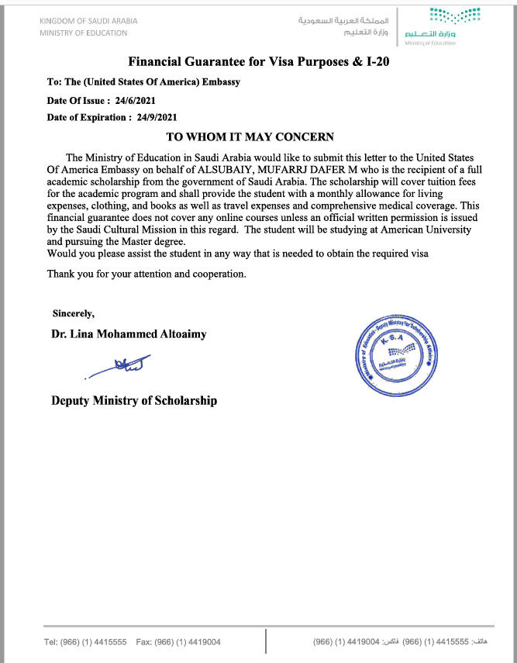

Final SACM Financial Guarantee that students will receive after arrival in the US:
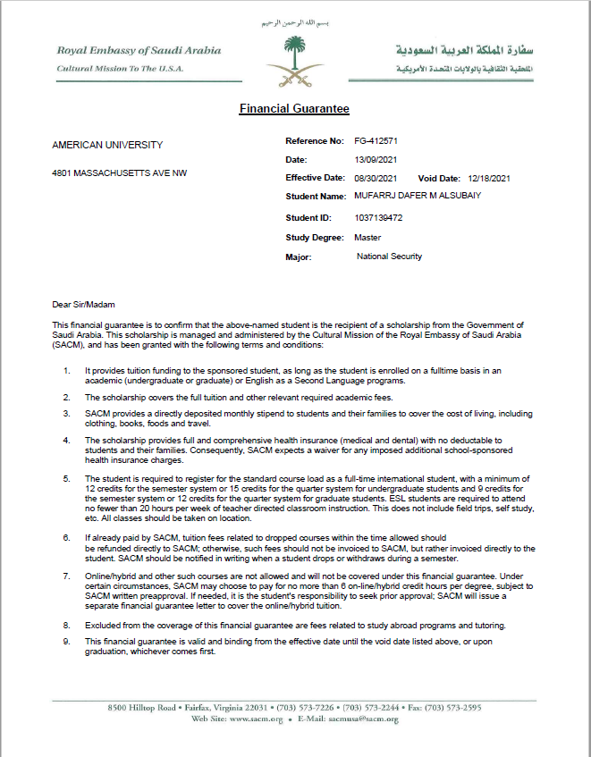

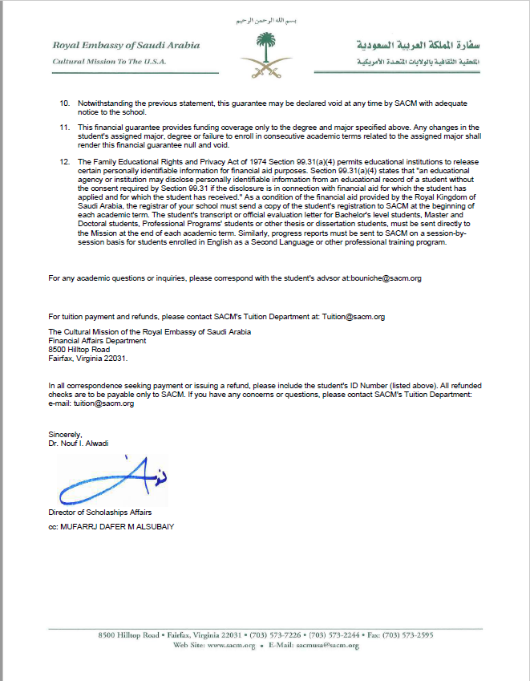
Acceptable SAMA Support Letter
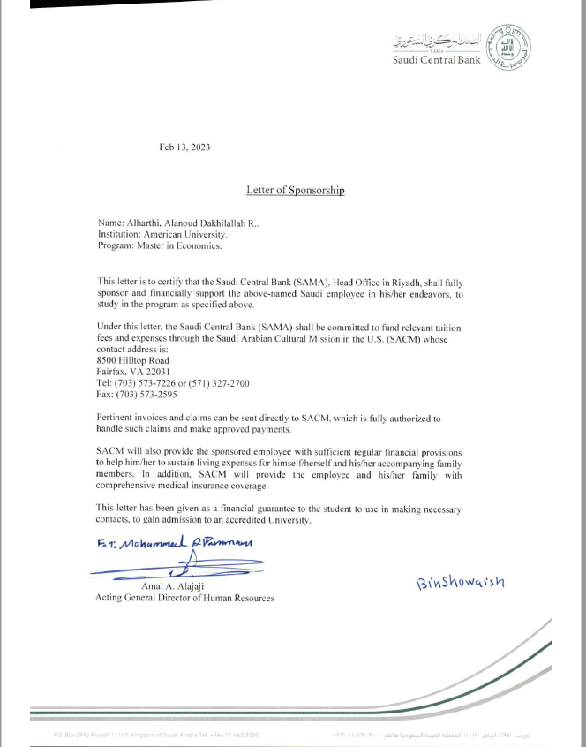
MPower Conditional Offer Letter:
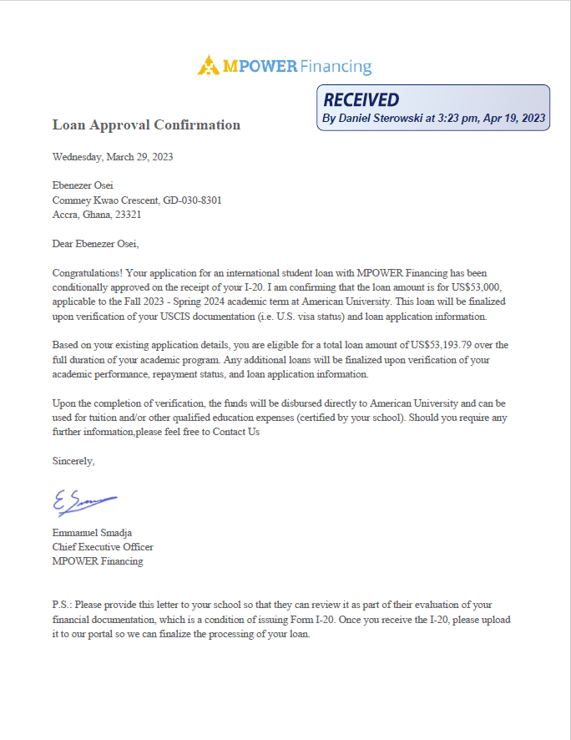
Financial Aid Loan Certification Example:
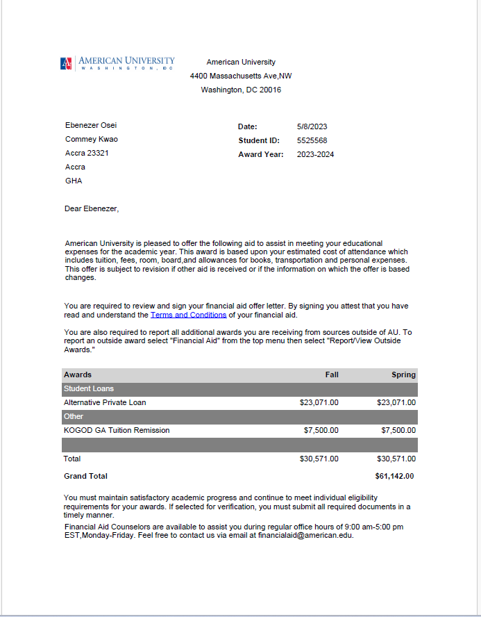
Example WCL Scholarship:
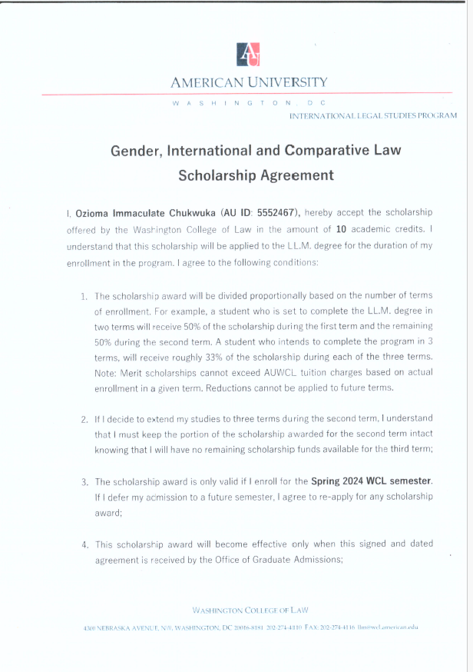
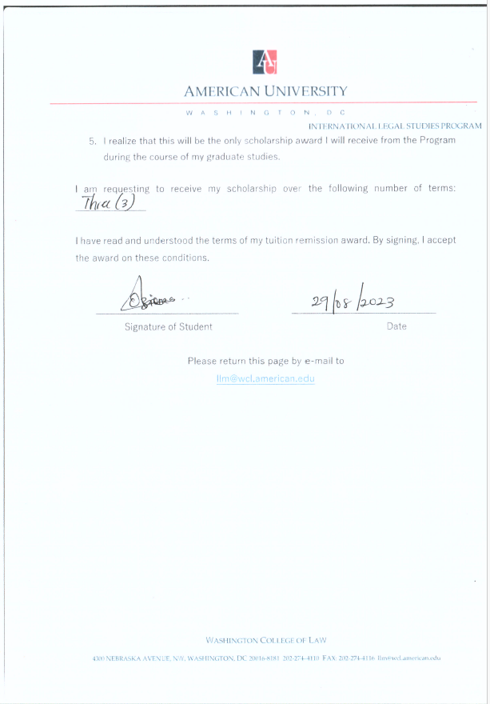
Example Athletic Scholarship:
